CNN model prj - cast, variable, constant (tensorflow)

https://www.kaggle.com/datasets/haesunpark/oxflower17/data

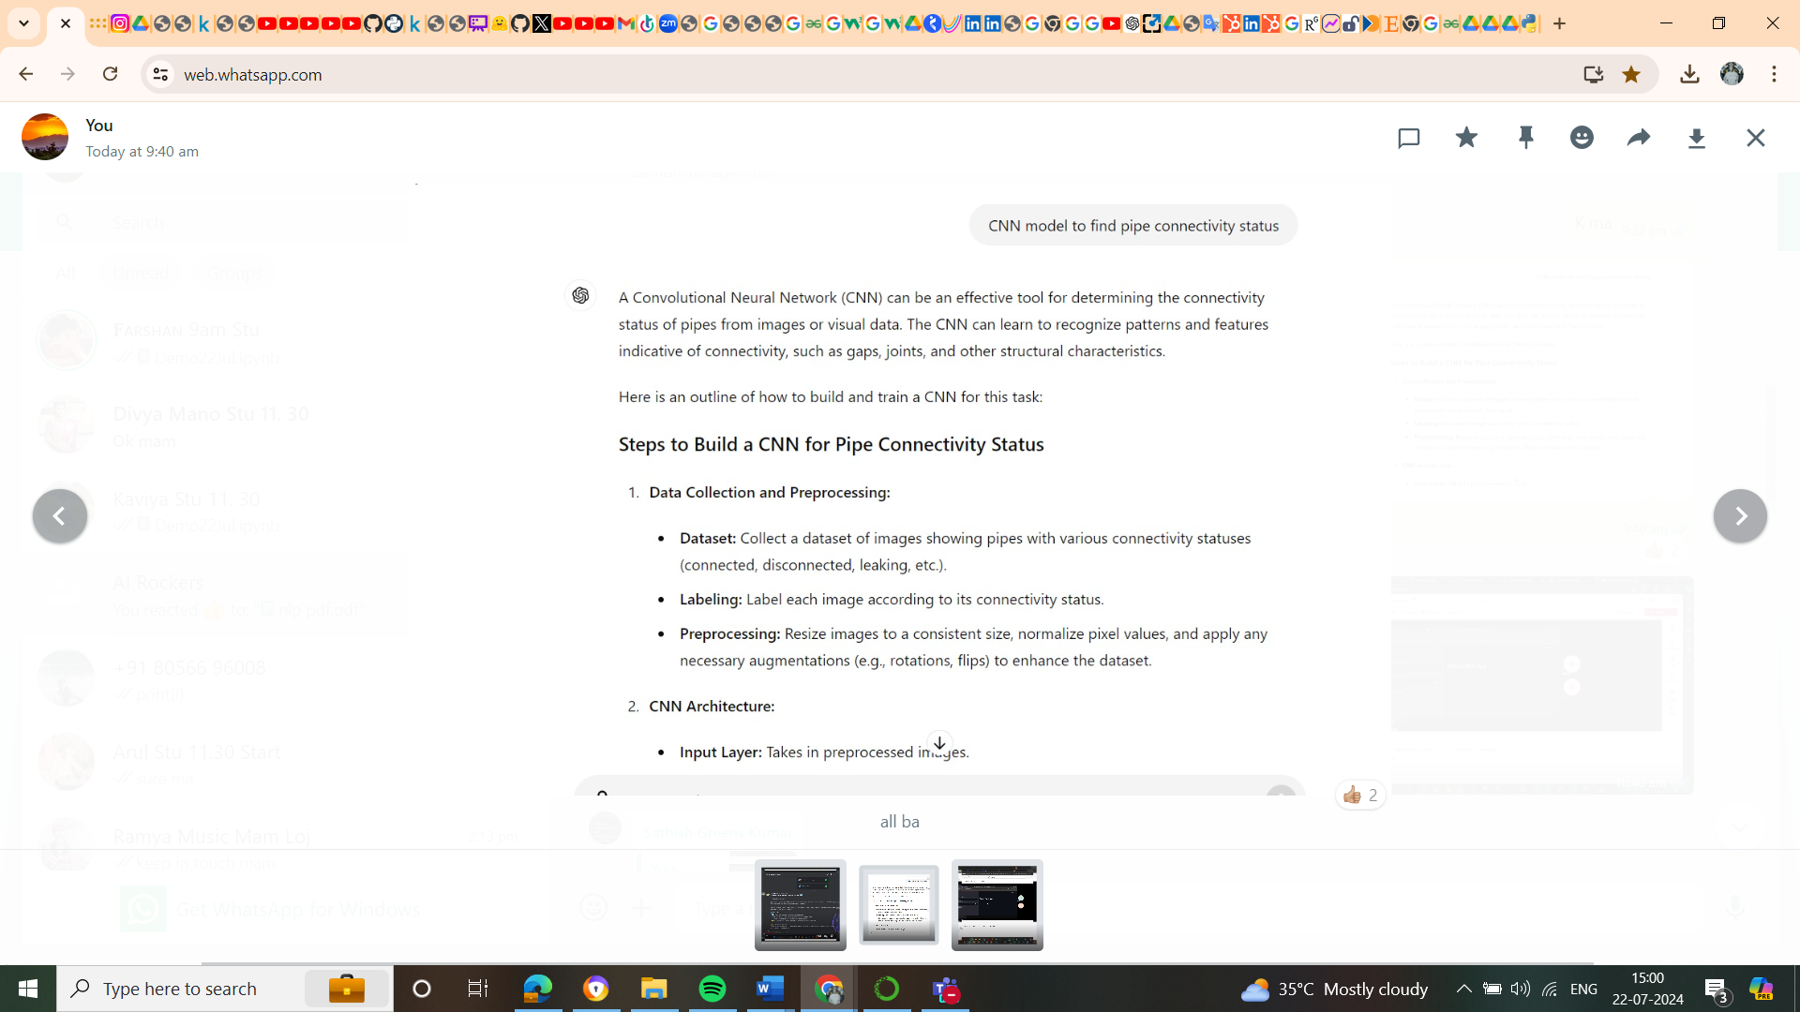

NLP Appli:

Sree in iphone, Amazon alexa, spam filter in Gmail

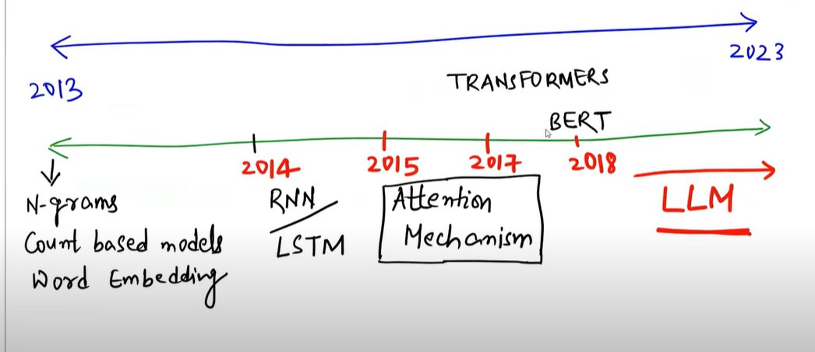

Asish sir no-

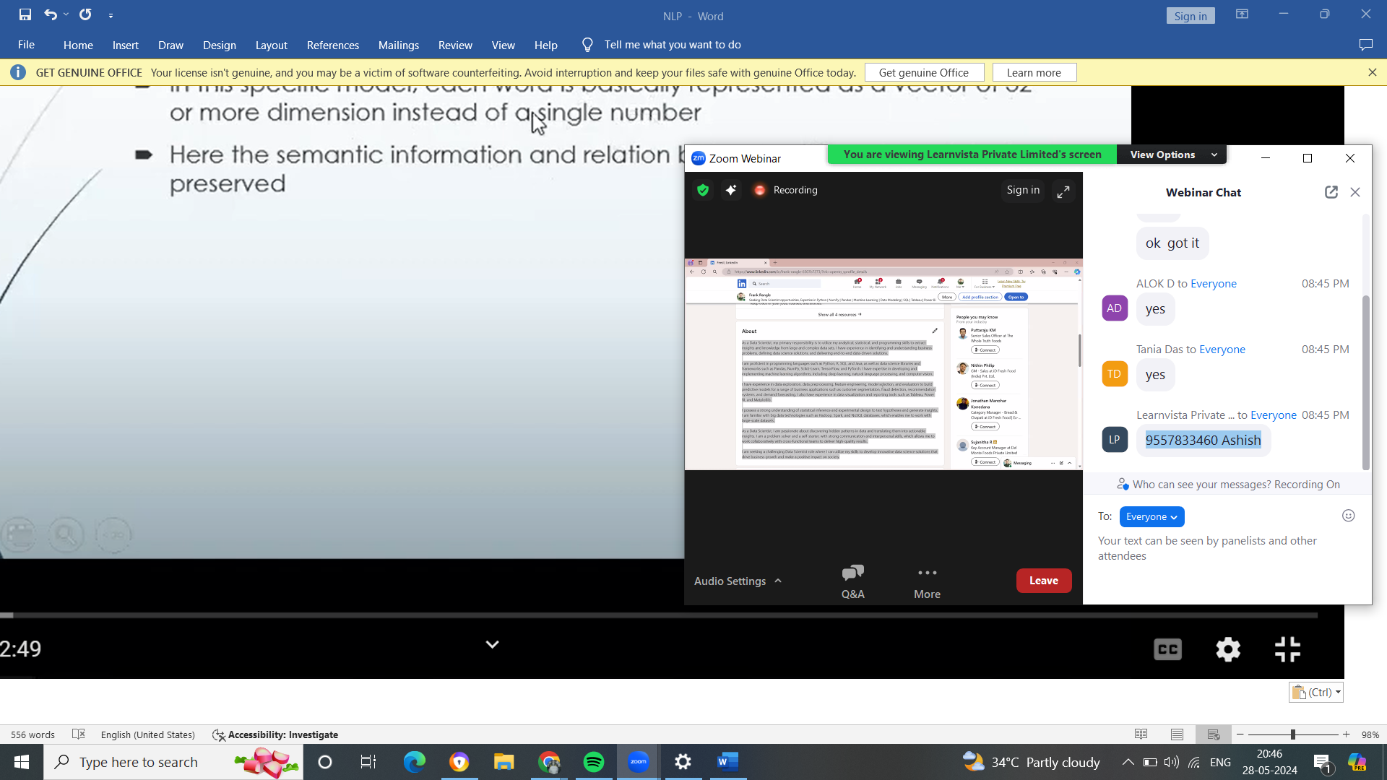

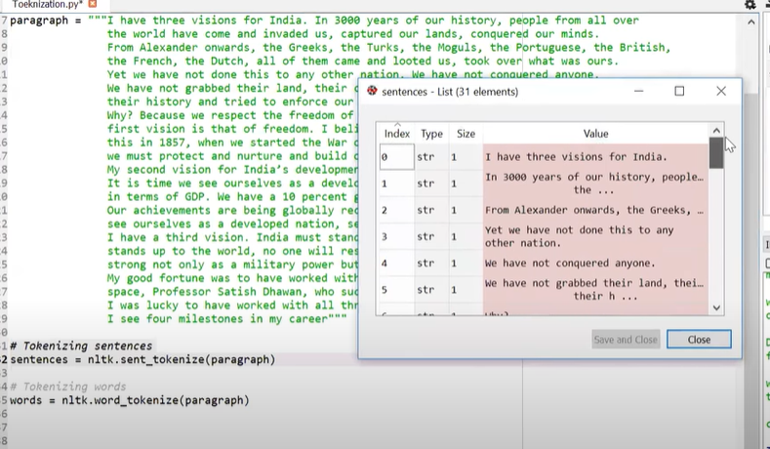

**Tokenization**

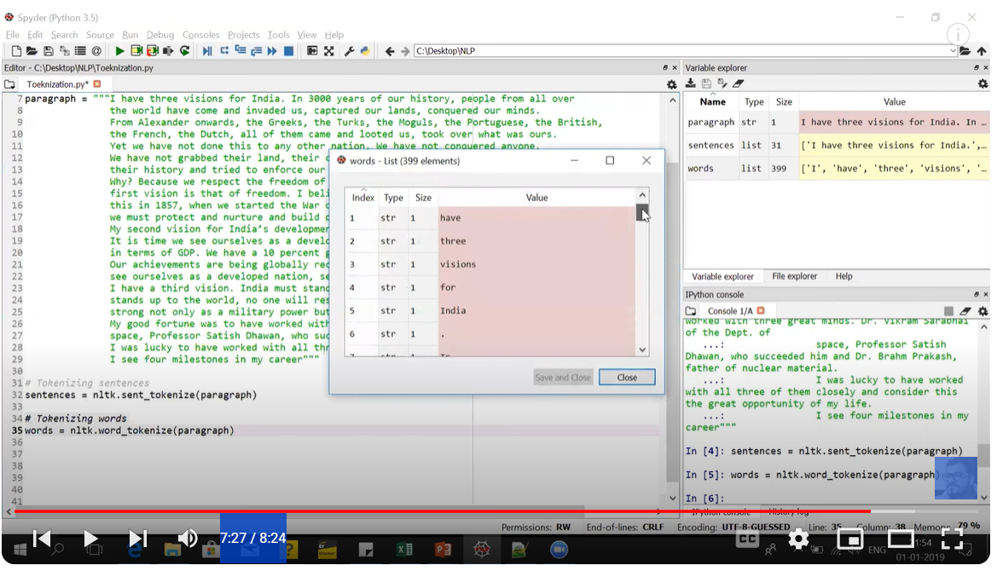

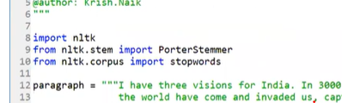

From nltk.stem import wordnetlemmatizer

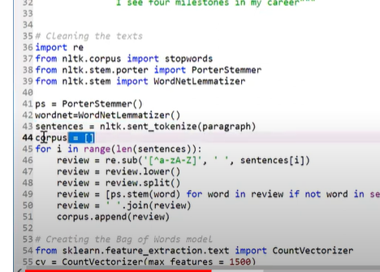

From sklearn.feature_extraction.text import countvectorizer – bag of wods

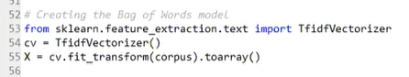

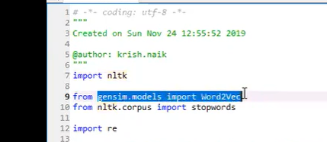

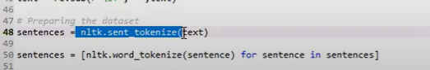

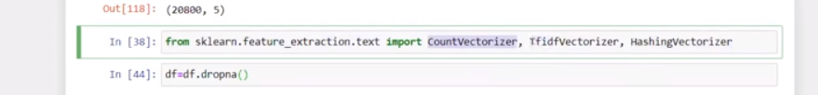

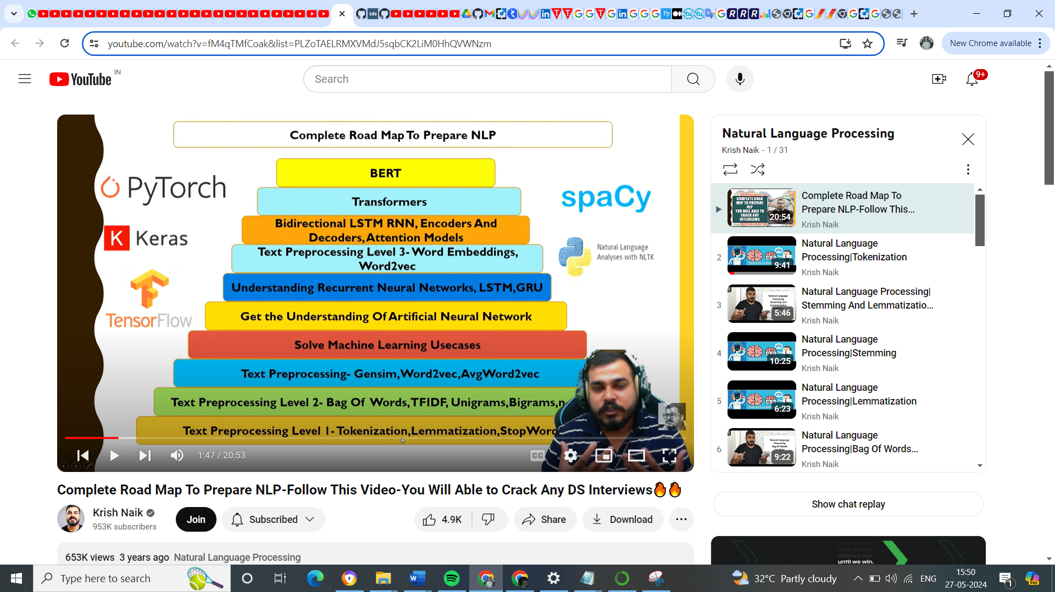

Draw back of bag of word, TF-IDF

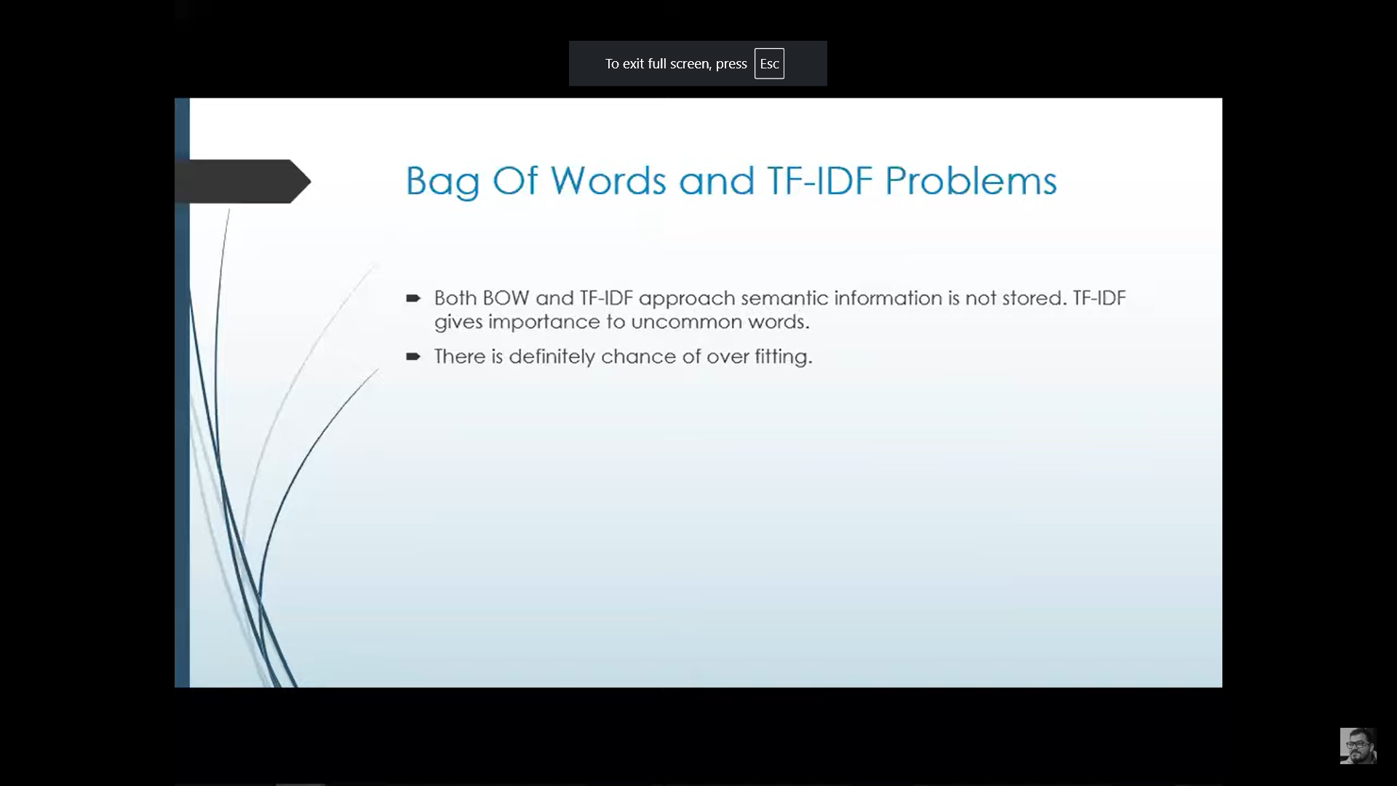

<https://www.geeksforgeeks.org/auc-roc-curve/>

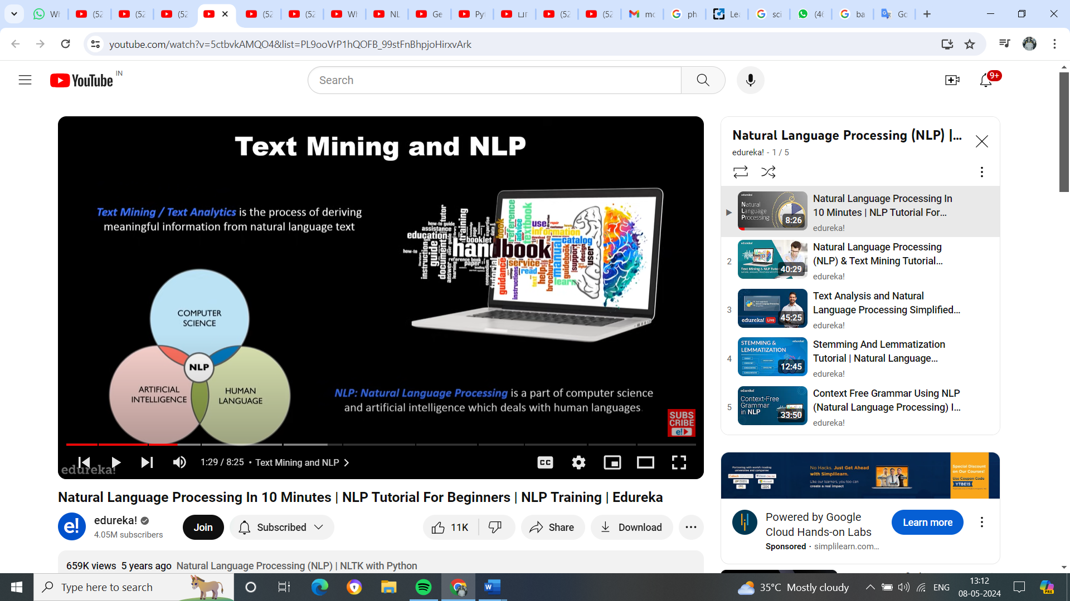

Text mining deals with structure data and drive the high quality info from text

<https://www.youtube.com/watch?v=5ctbvkAMQO4&list=PL9ooVrP1hQOFB_99stFnBhpjoHirxvArk>

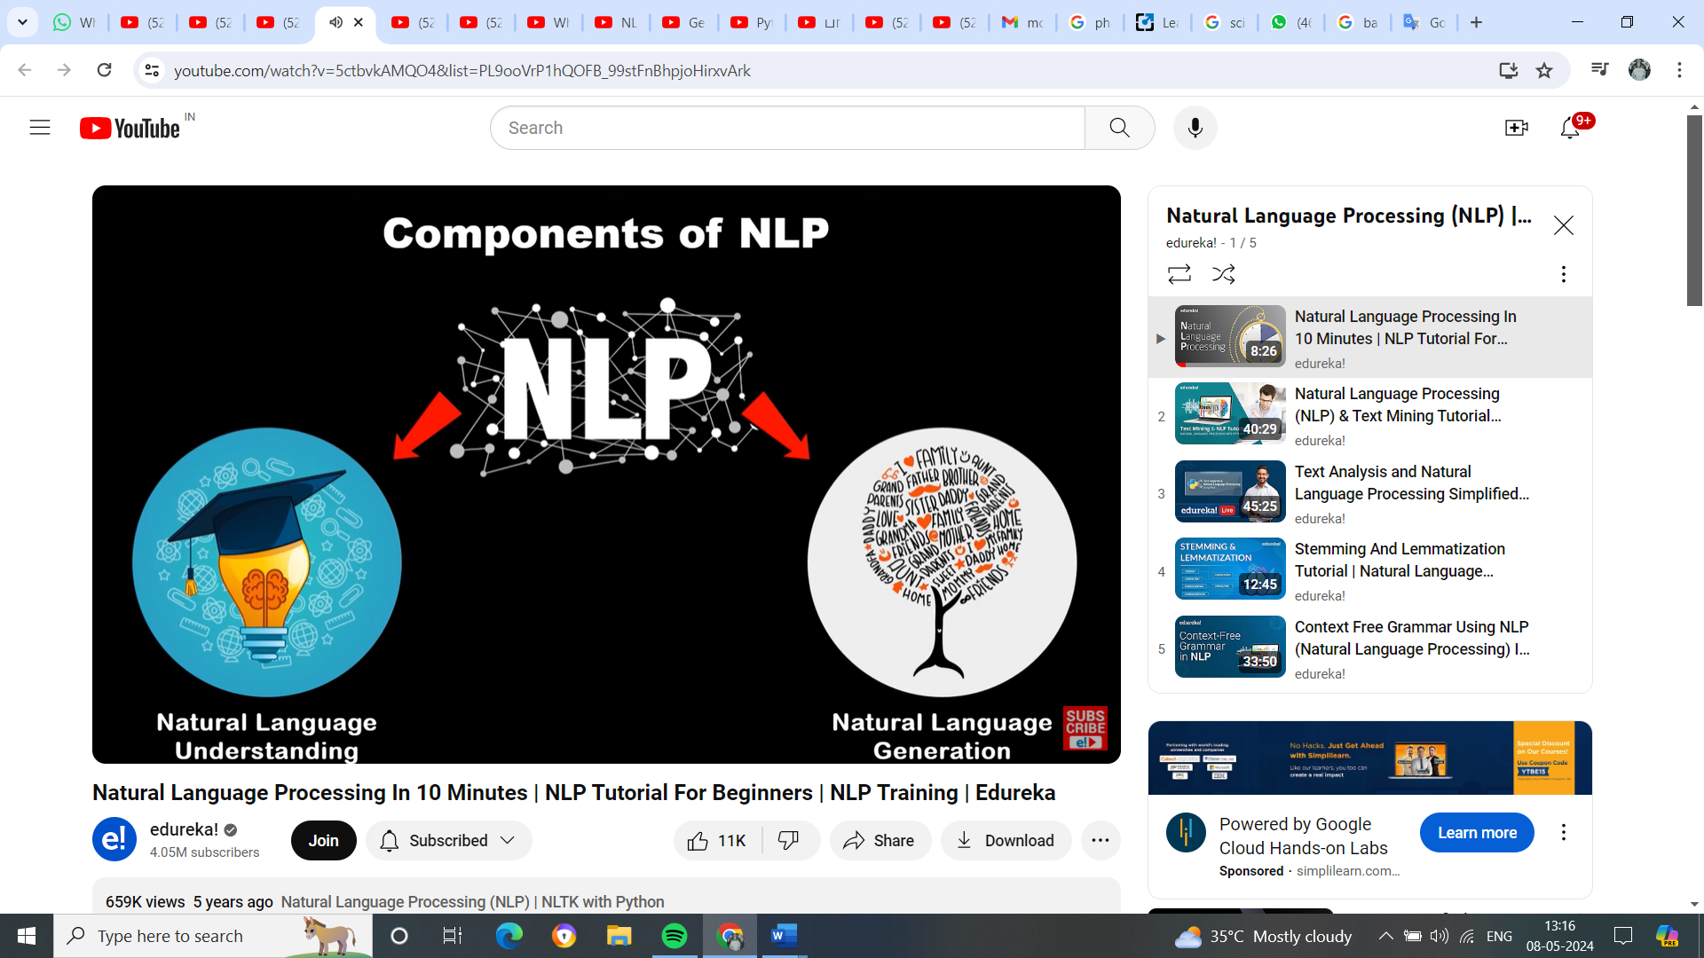

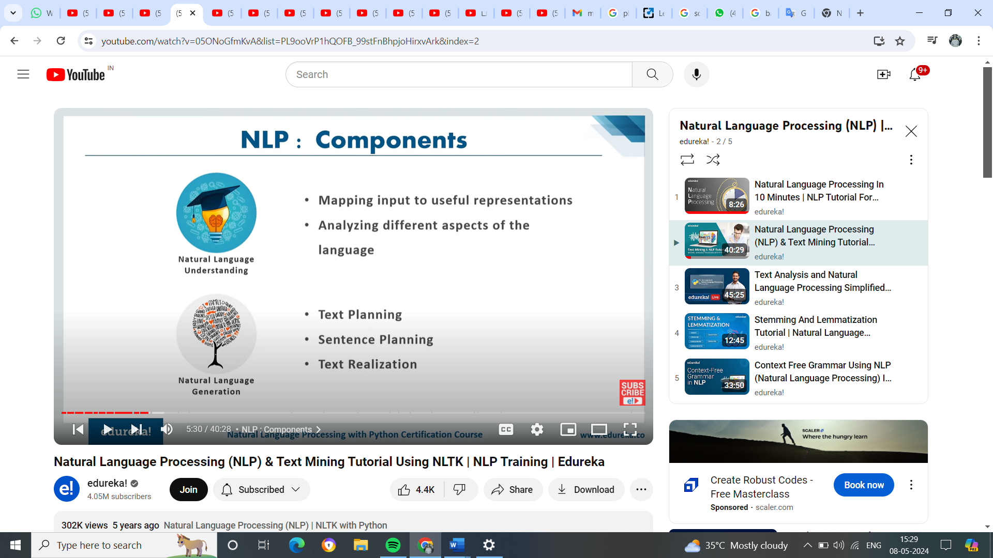

NLU mapping the given input into Natural lang into useful representation and analyse those aspect of the lang where generator is the process of producing meaningful phrase and sentences in the form of NL from some internal representation.

NLU is very harder than NLG, bcz NLU will take lot of time & lot of things to understand particular language speacilayy if not a human being.

In NLP lot of steps involves like,

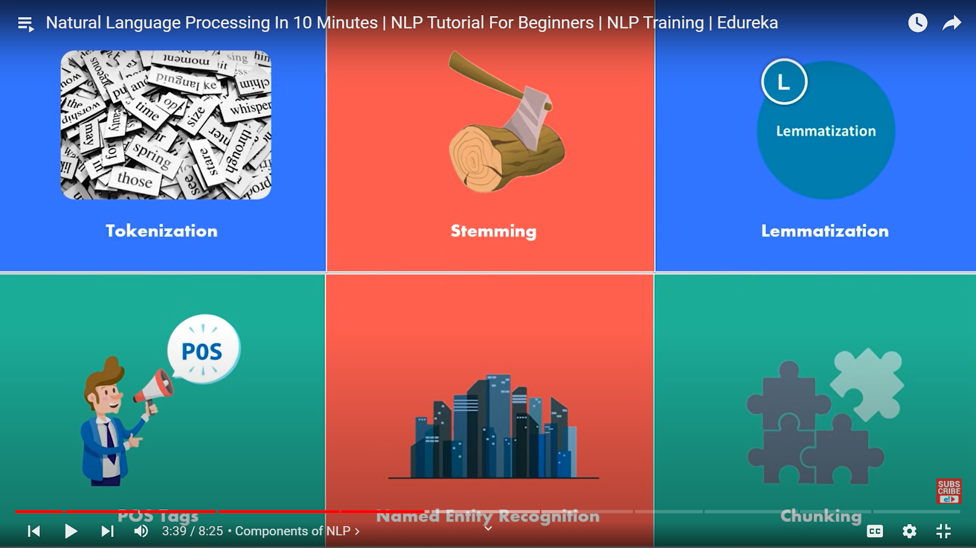

NLU

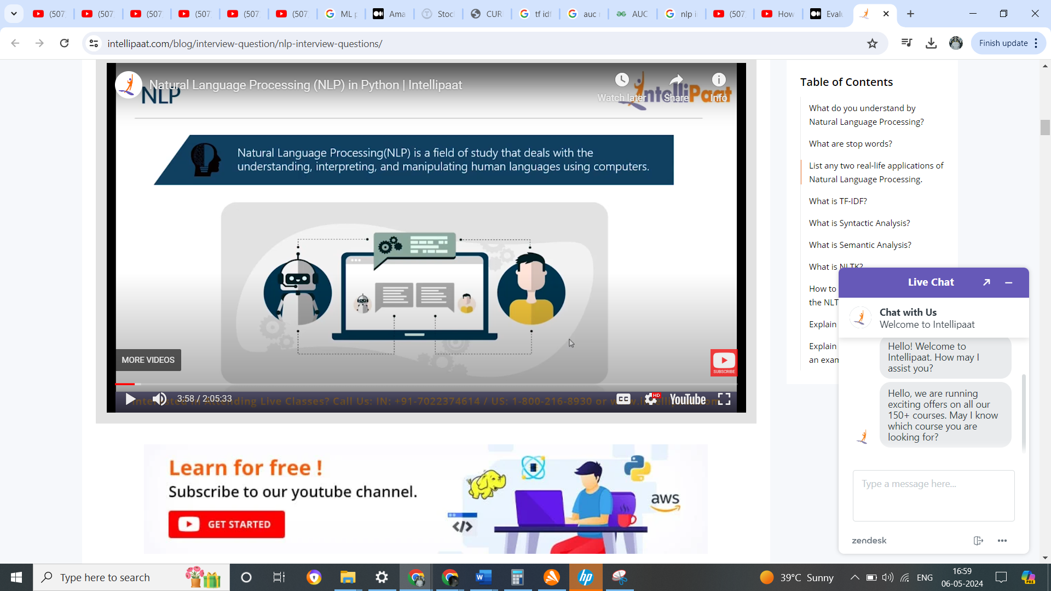

NLP in text mining

We are getting data from mail, sentiment , SMS, web pages, with the help of NLP we process all this text data for diff purose for character recognition, sentiment analysis & spell check

Vector type:

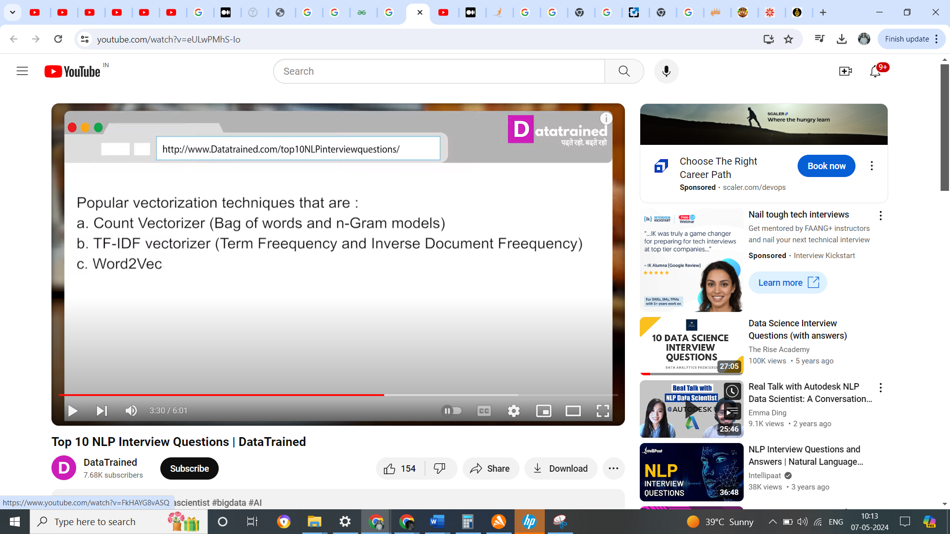

NLP life cycle:

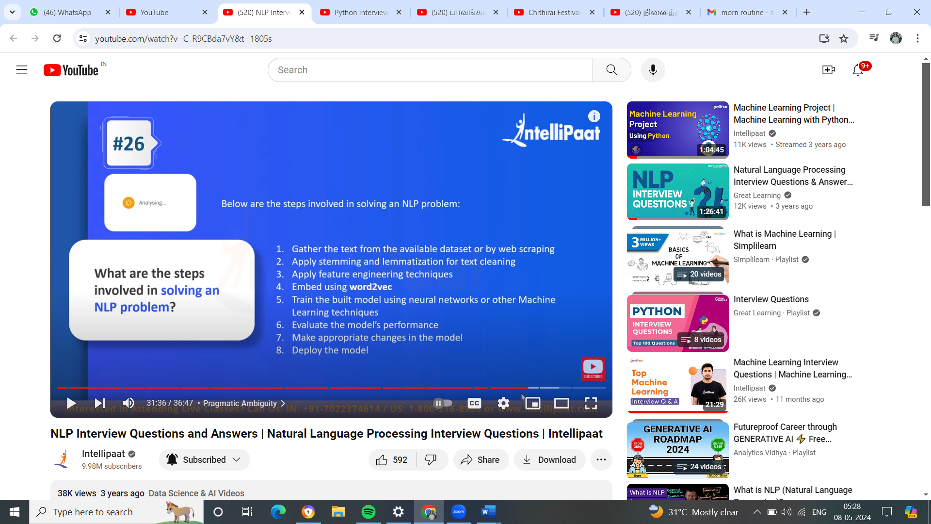

Precision & Recall

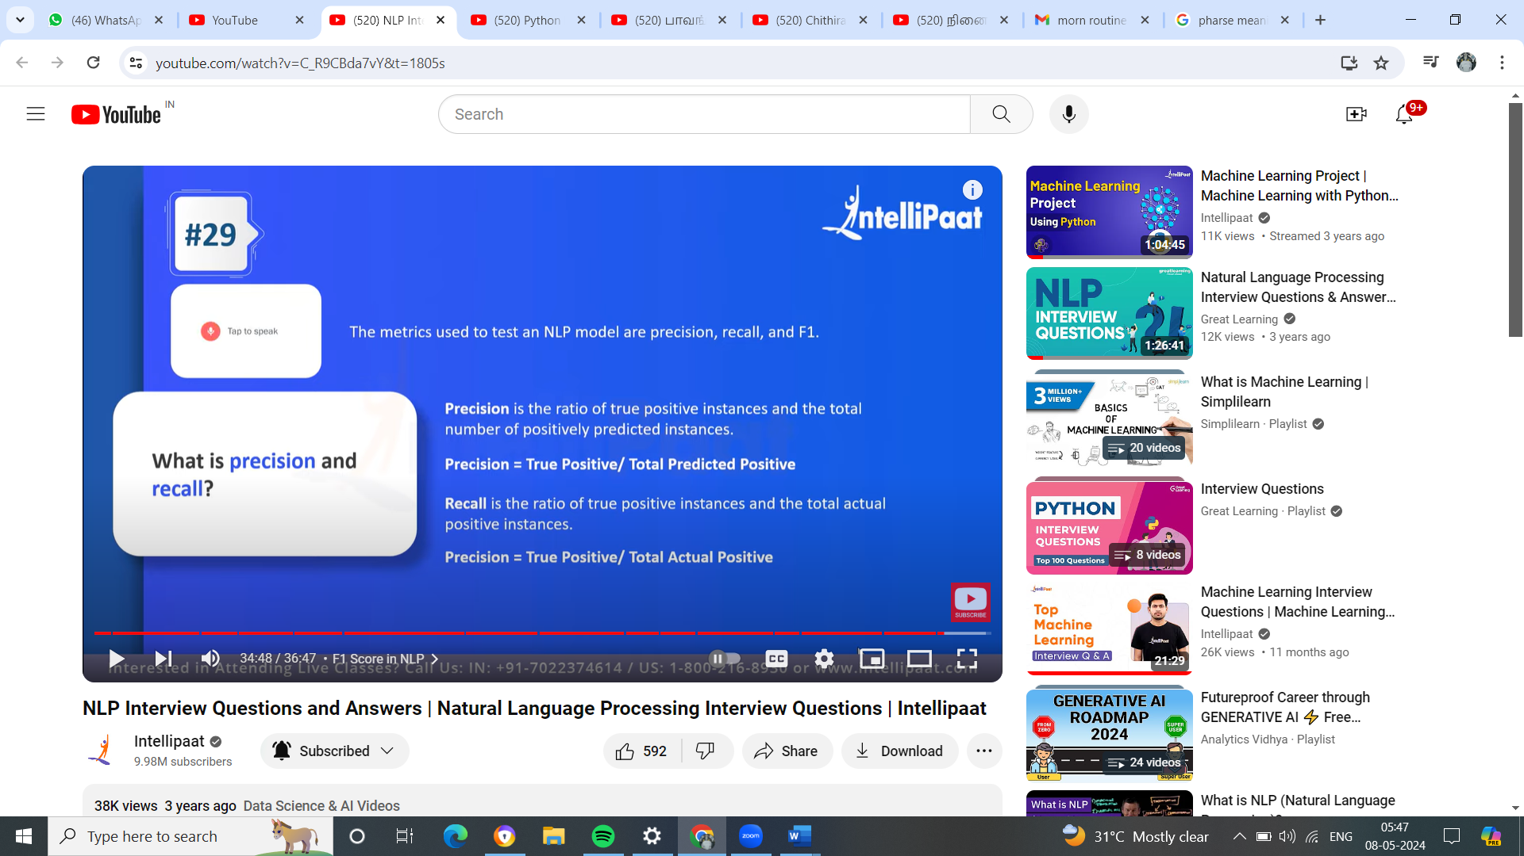

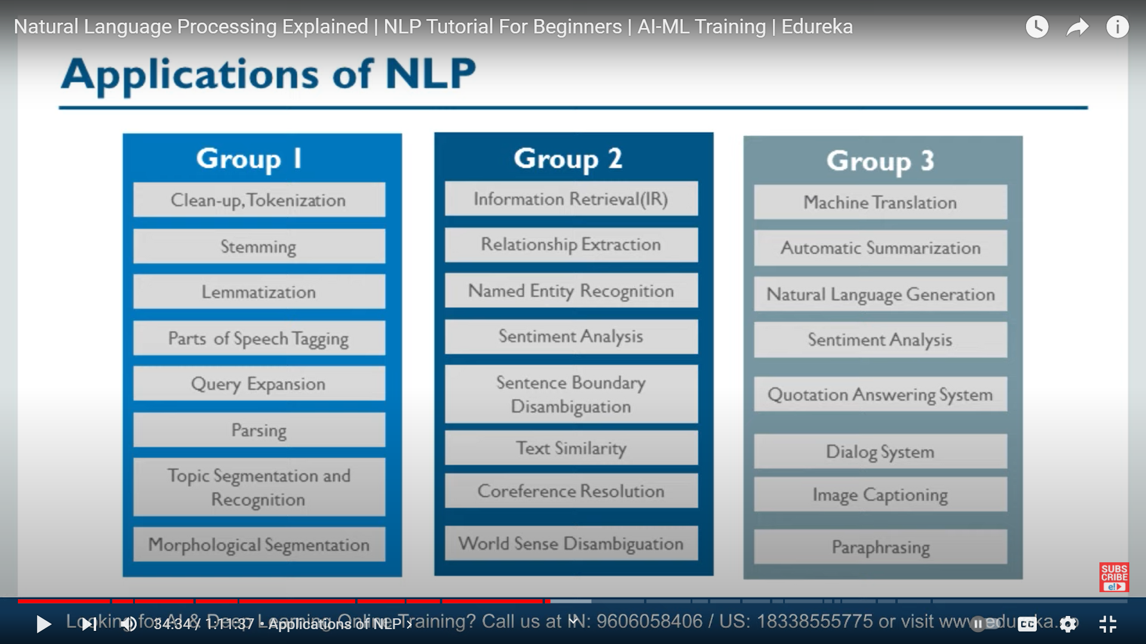

Tokenaization & lemmatization is both are similar but lemmtization is more advance it can understand parts of speech like verb, adjective, adverb , pro-noun, noun

Parts of Sppech - after tokenization the sentence into small word, it ll identify the each word as noun, adjective , proverb or verb

Query expansion - is something we used in google search, if suppose we are searching the word’ SHOE’, the google search resuuly doesn’t give the result of shoe, it ll give show the result of boot, slipper

Topic segmentation – if we have 100 novel PDF, it cover drama, we can categorize this novel as drama, thriller, comety, NLP will categorize this 100 novel into 3 0r 4 category based on the topic of the novel like this

Sentiment analysis – base on the customer sentiment in the form of twit during the election , we can take the analyseits with BjP or not…

Image Captioning – based on the scene, it ll give high level comments about the video and more over this is not sub-title.

Dialog system - chatter bot

Machine Translation – Google Translator

NLP used in credit card fraud detection

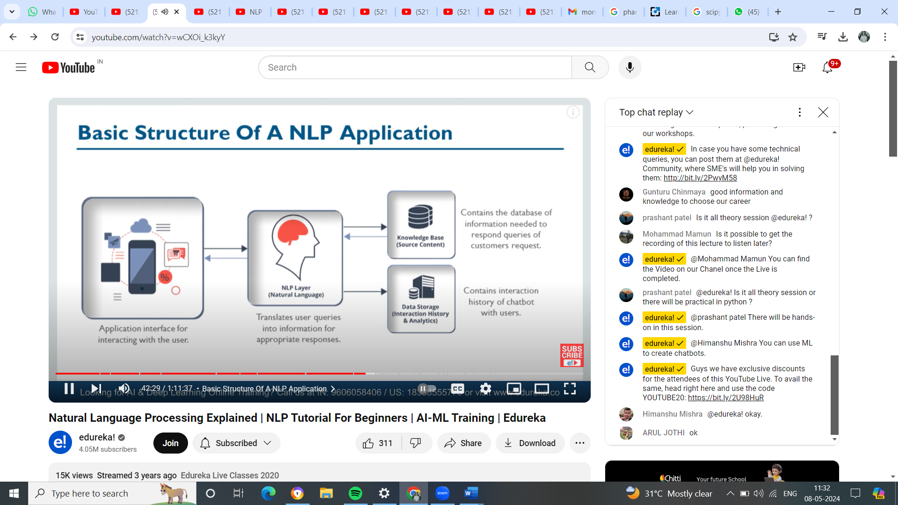

NLP will store the data for analytics & so that it will respond to the user very quickly in future & machine can understand as A R Rahman as music dir

NLP will lead Ambiguity –

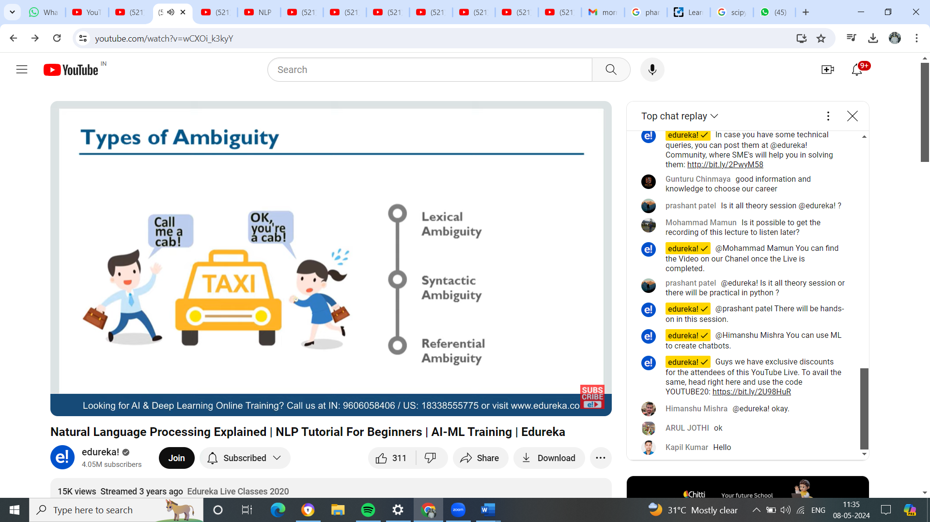

**Lexical Ambiguity** – Ambiguity happen due to particular word which has multiple meaning

But the NLP meaning as she wants life partner…

Eg 2 – fisher man went to bank ( 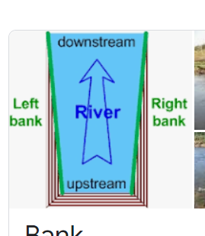

But NLP understand as actual bank (bank of America like that)

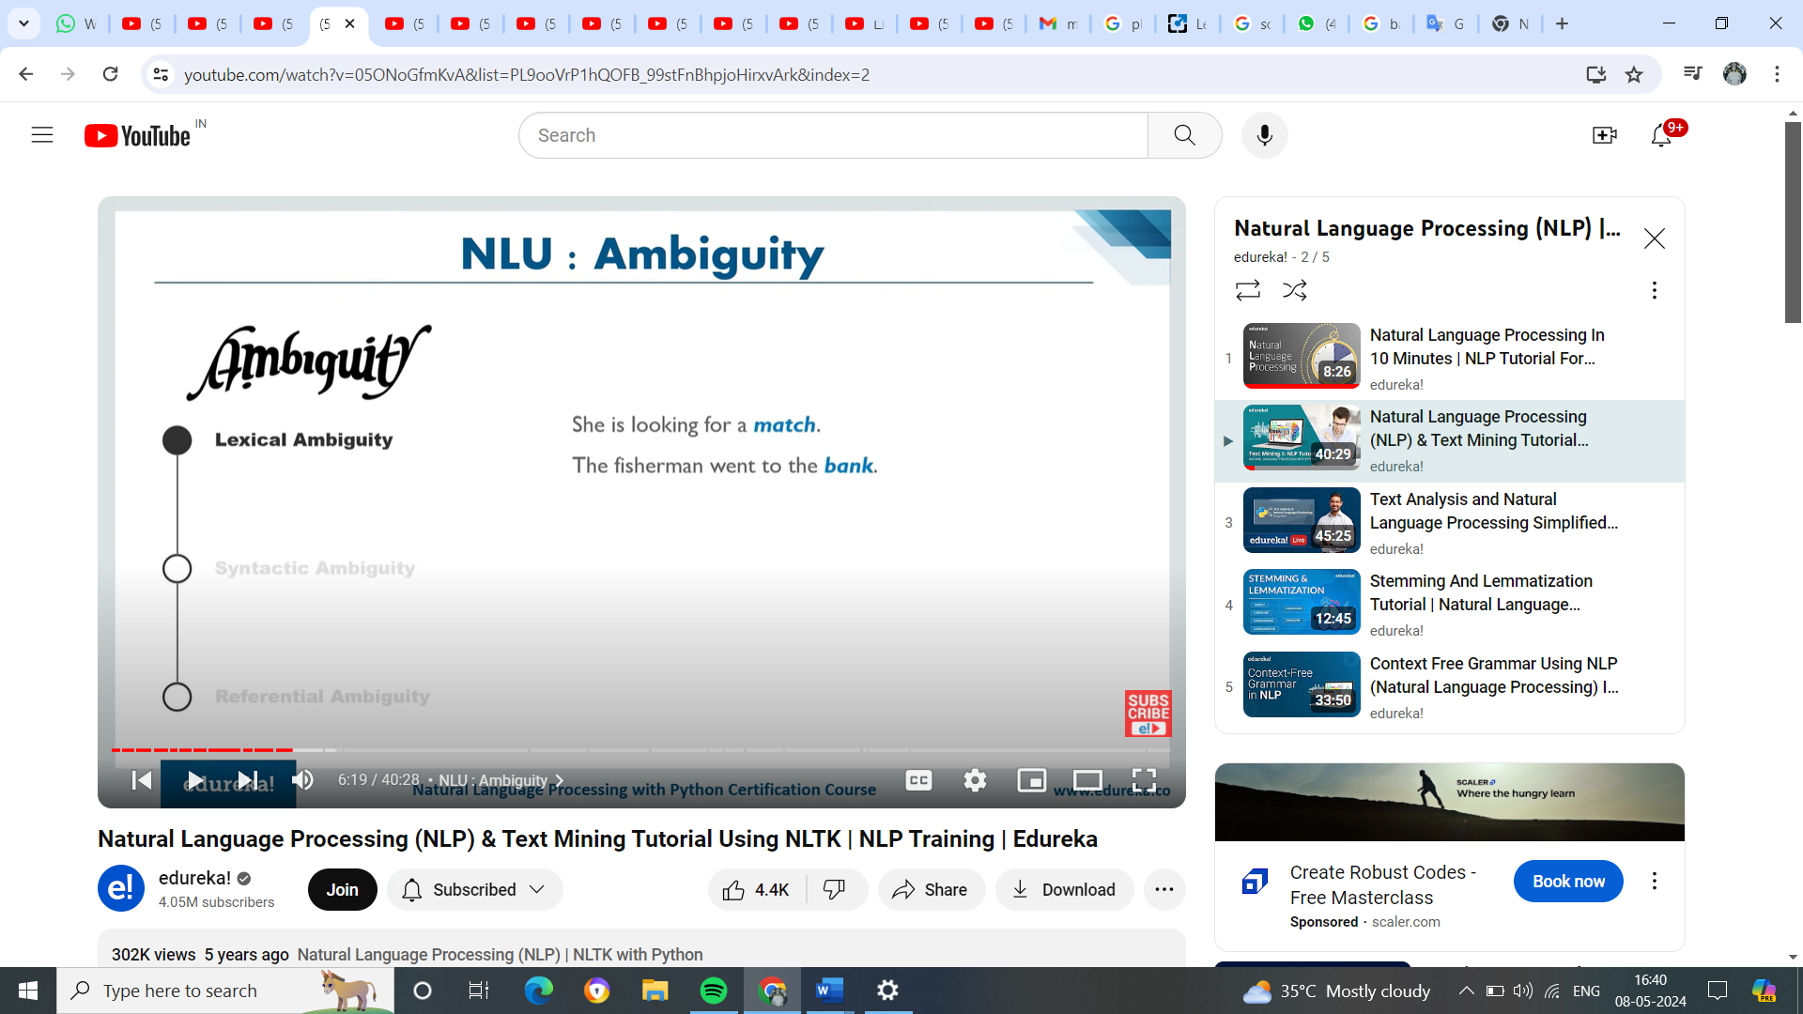

Syntactic : - Ambiguity due to gp of word or sentence

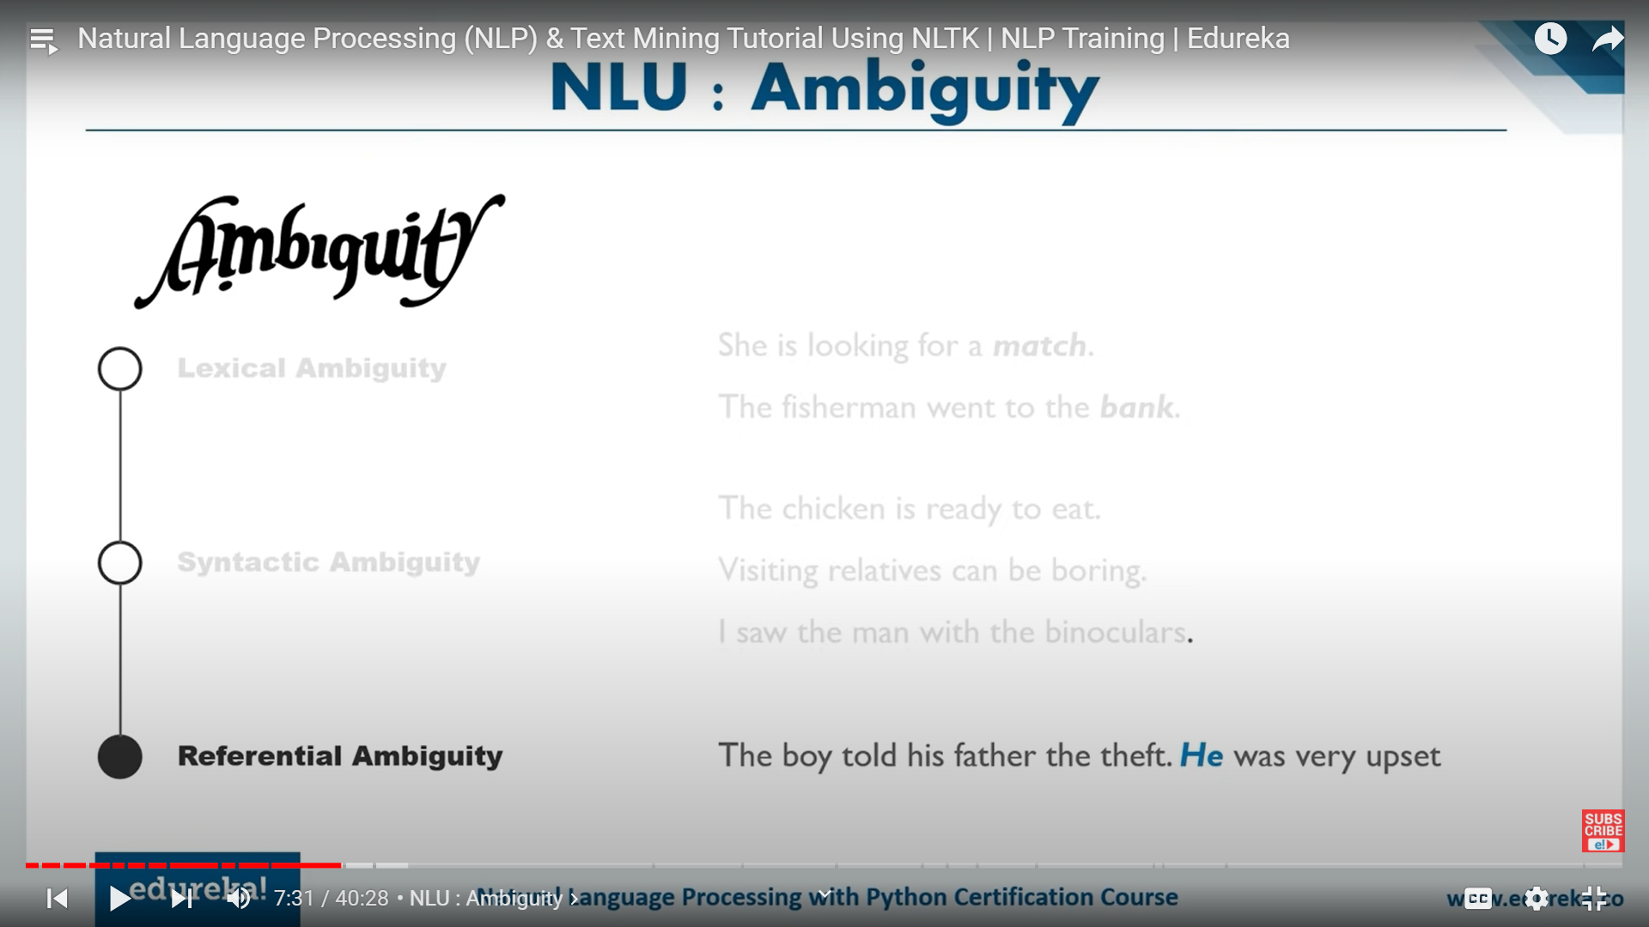

Either chicken is ready to eat their food or its ready for our people to eat chicken

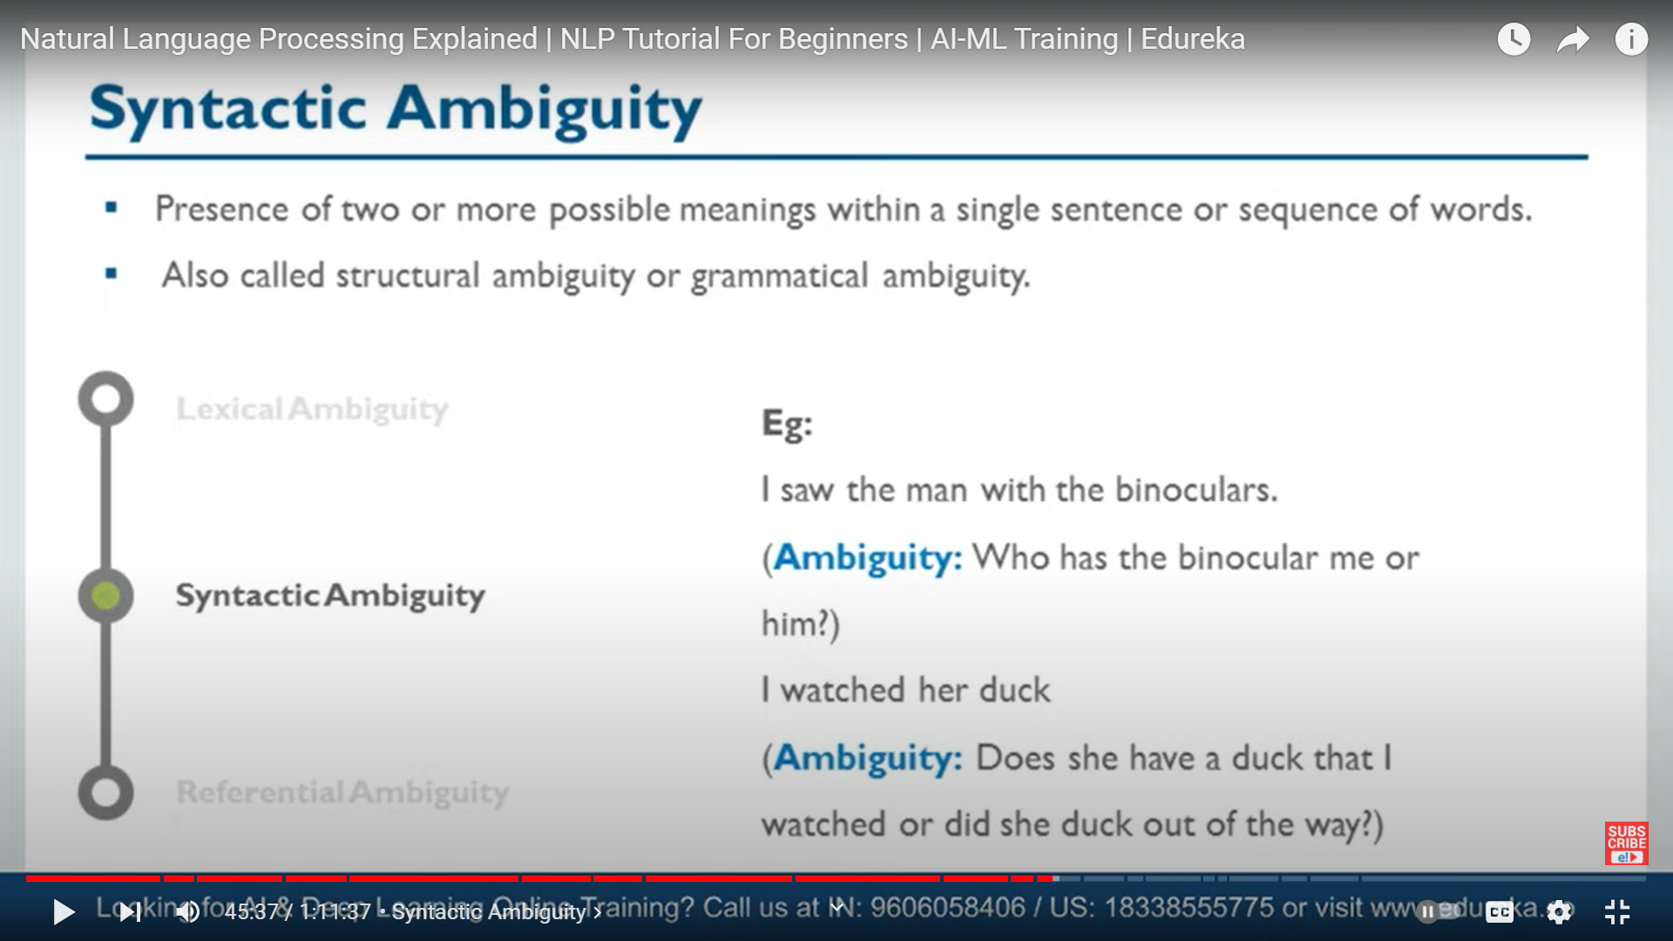

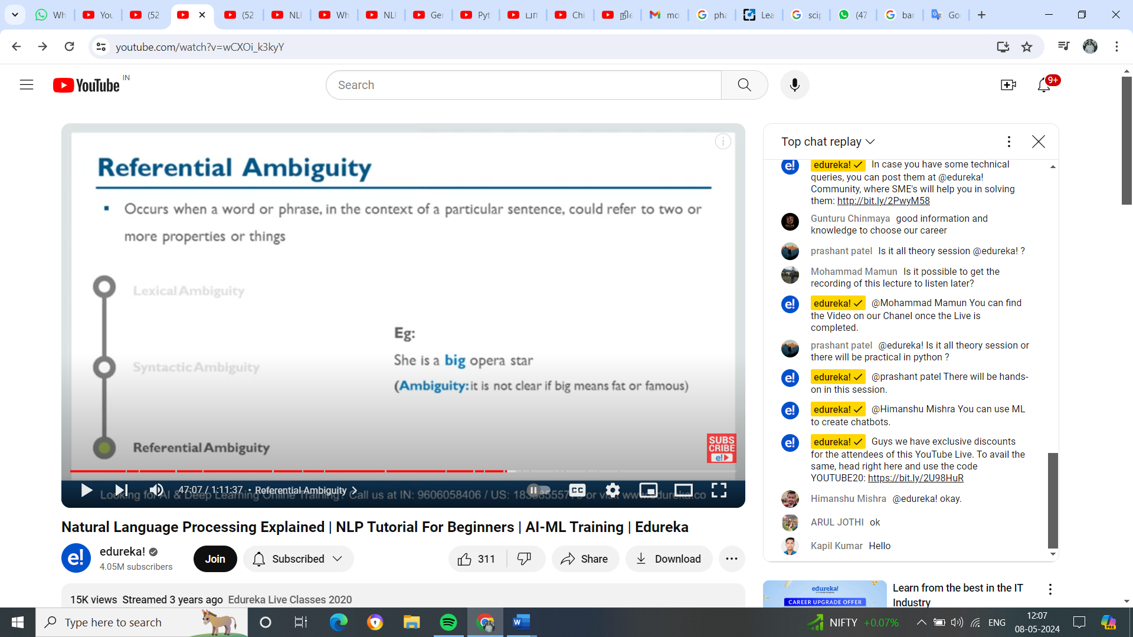

PreProcessing:

Token

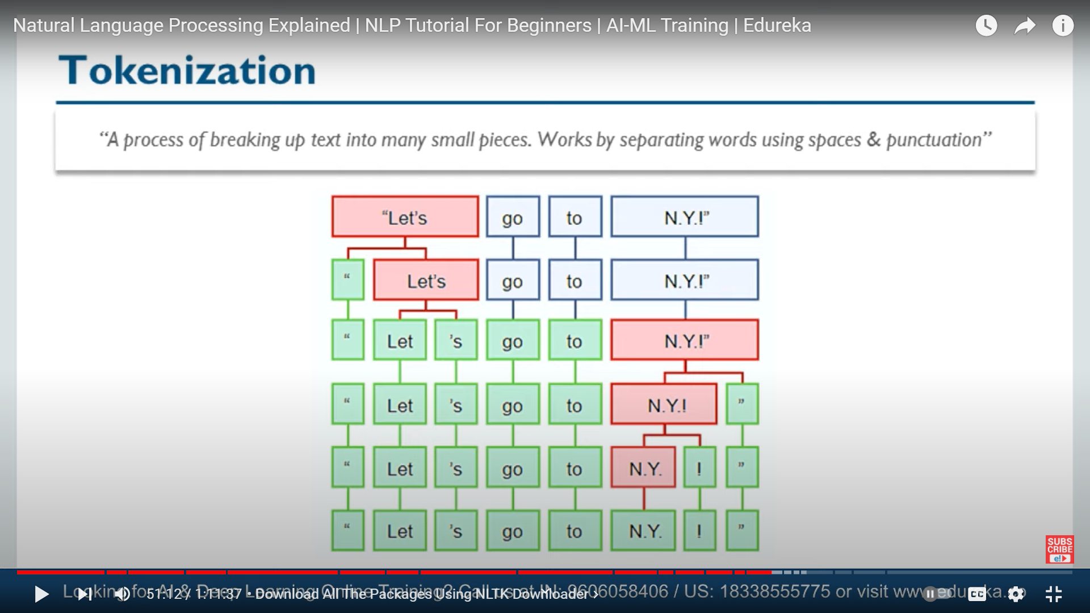

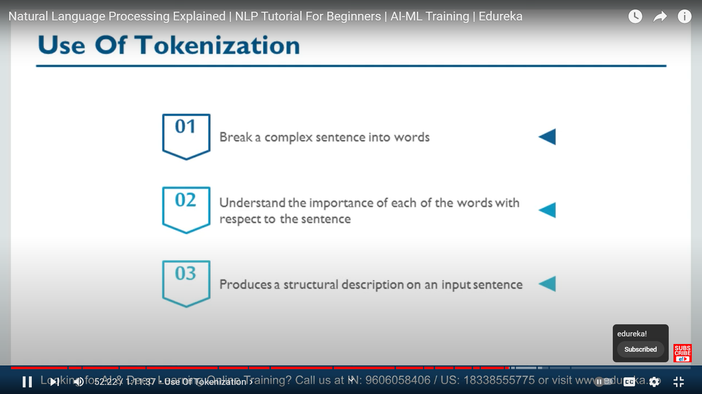

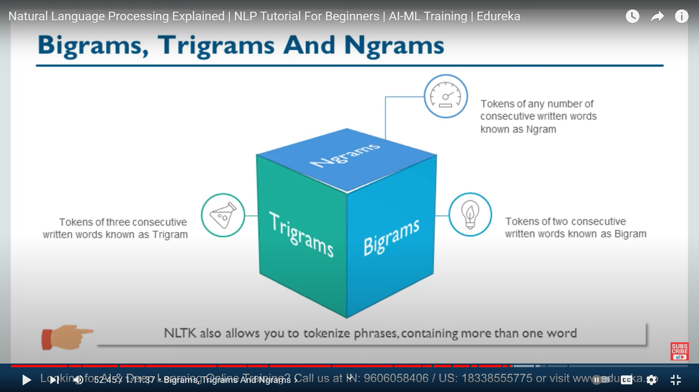

Stemming – finding the root word by removeing the prefix / suffix

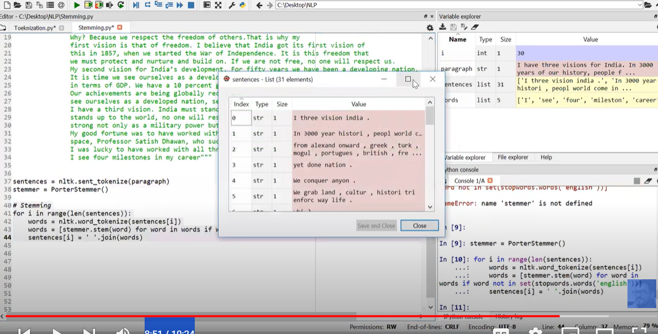

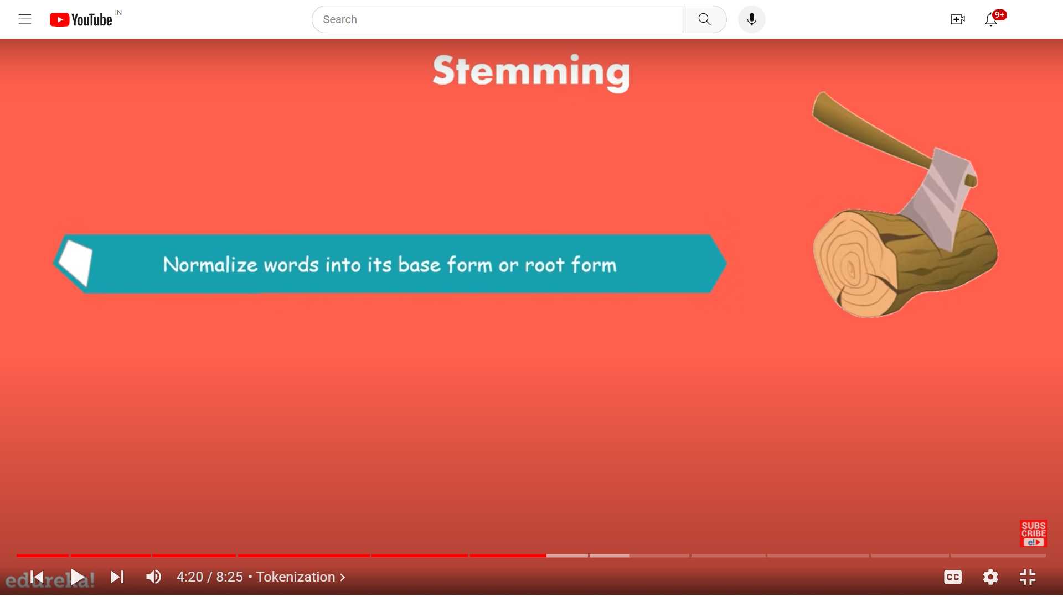

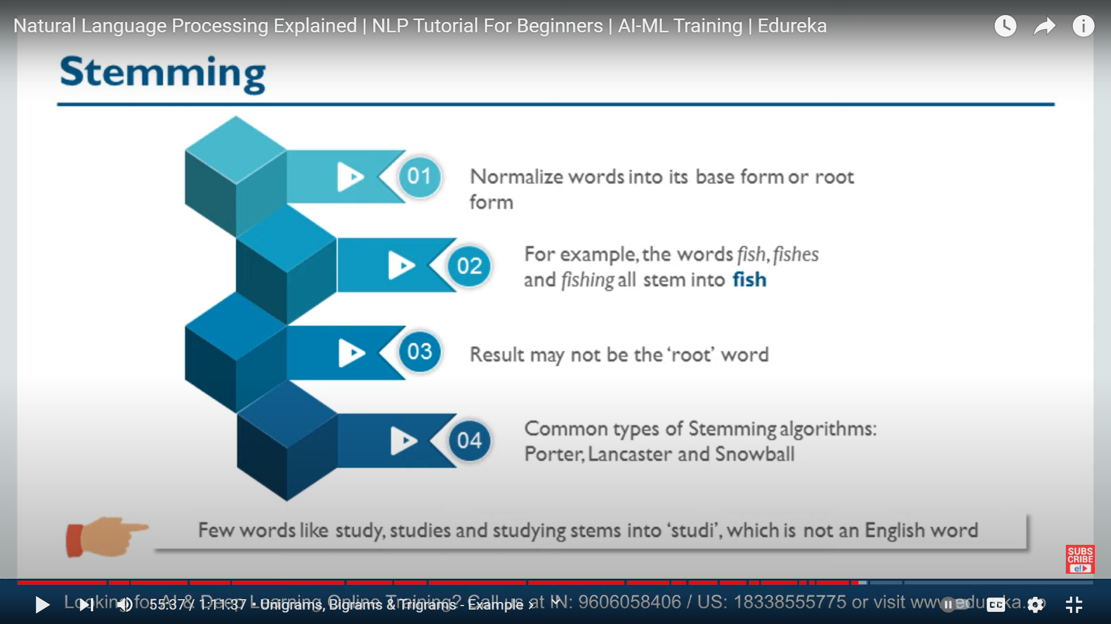

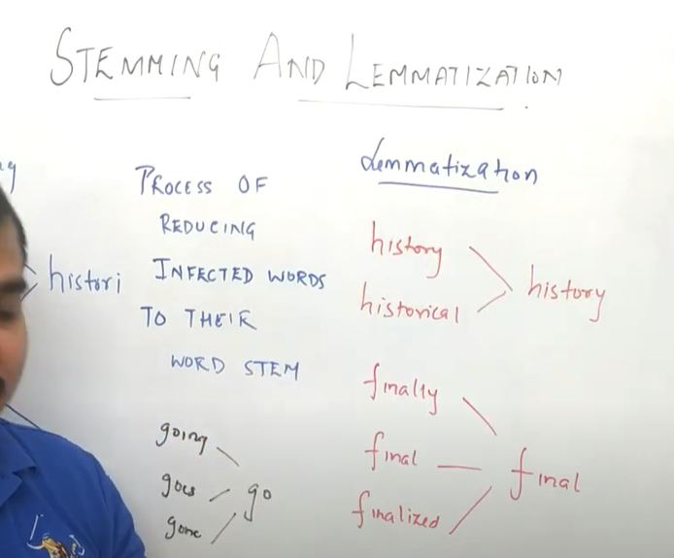

This kind of discriminate cutting won’t get success at all the time ,

Lemmatization – understand / consider the morphological analysis of word. To do show, we need detailed dictionary through which algorithm look the word link with root

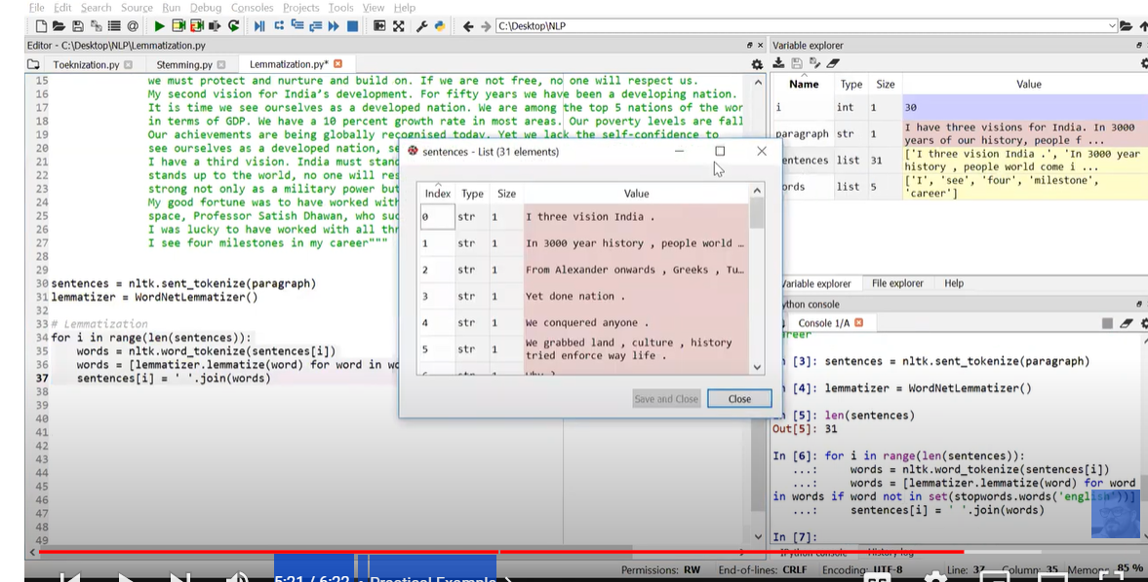

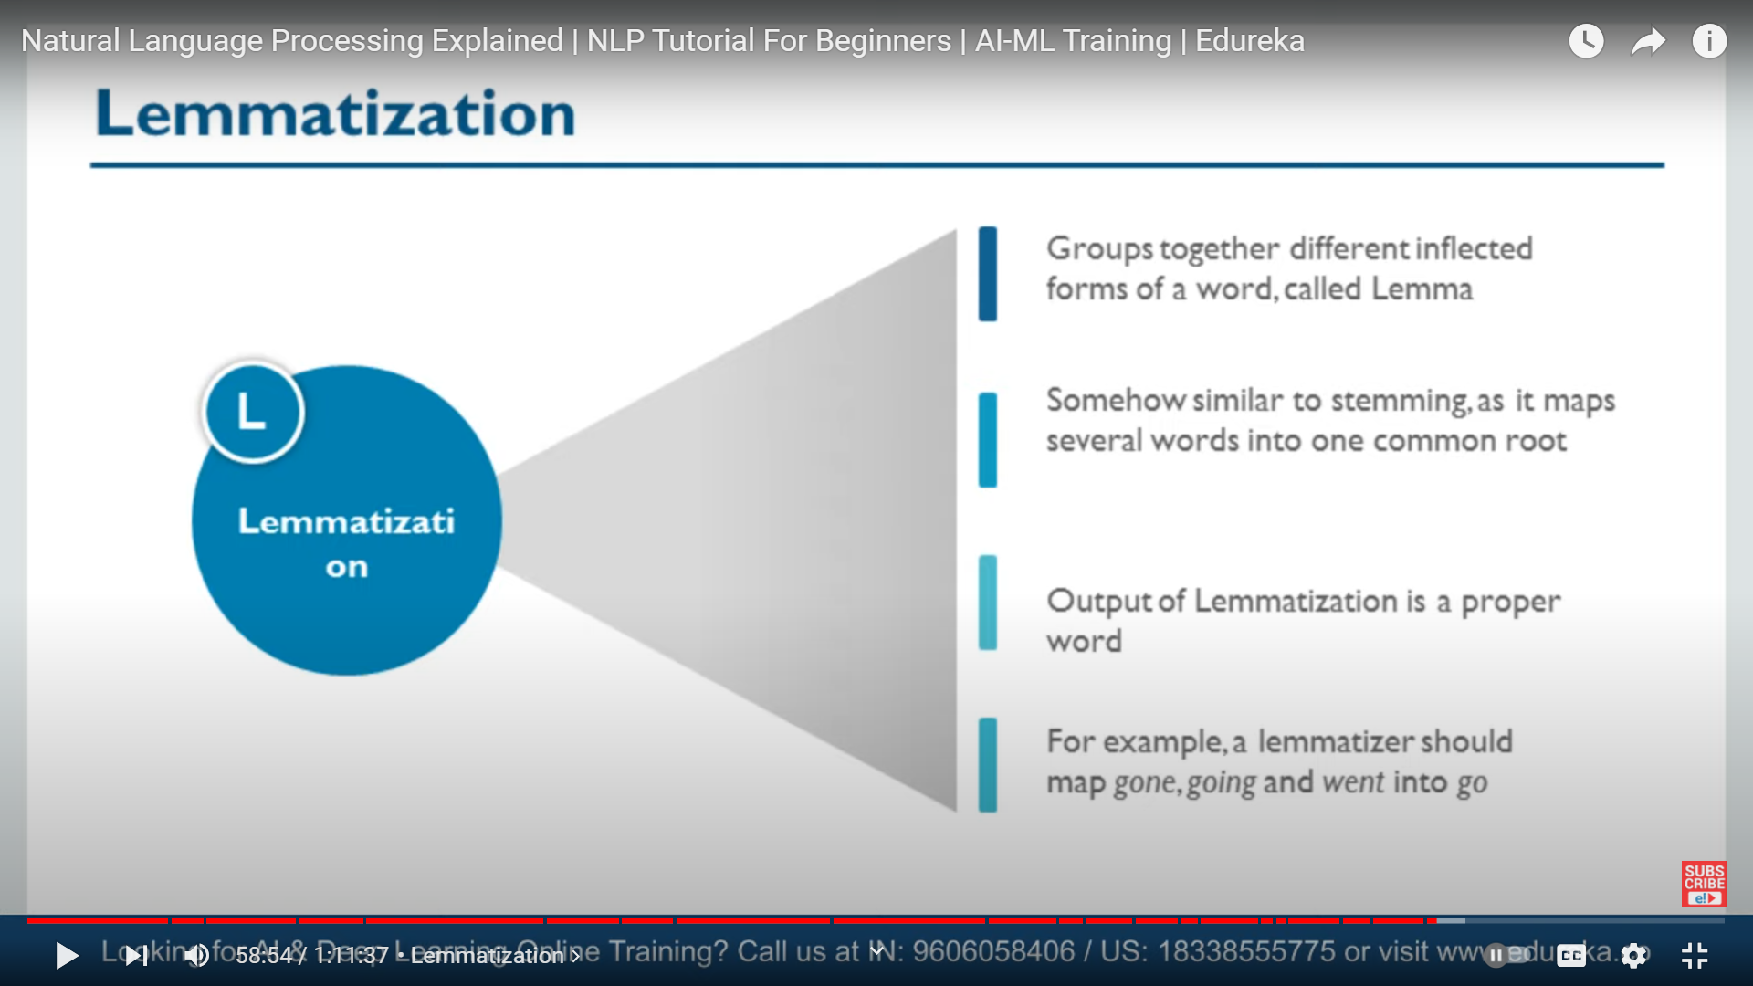

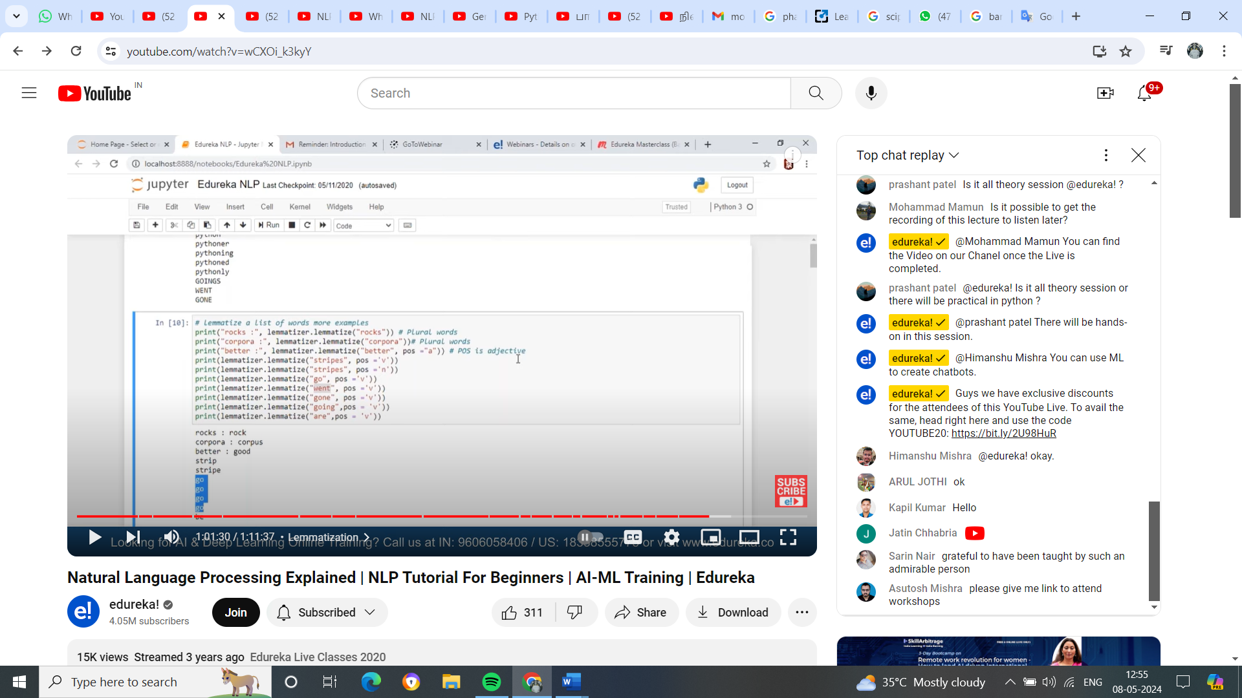

Stopword

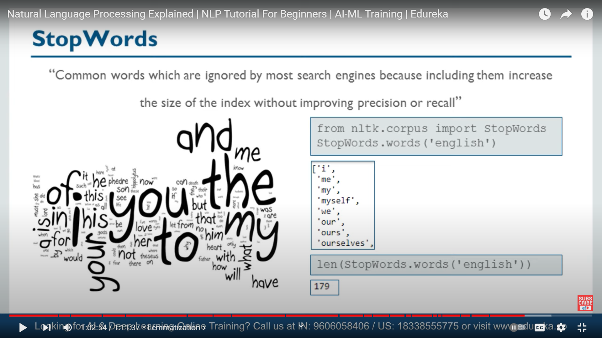

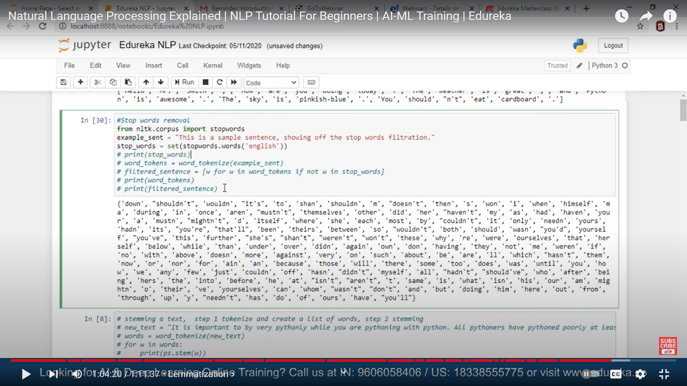

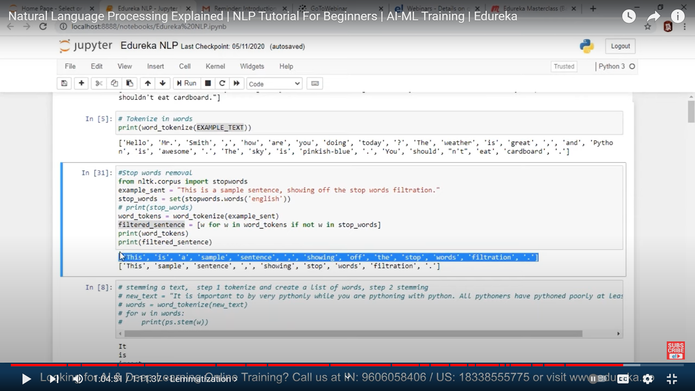

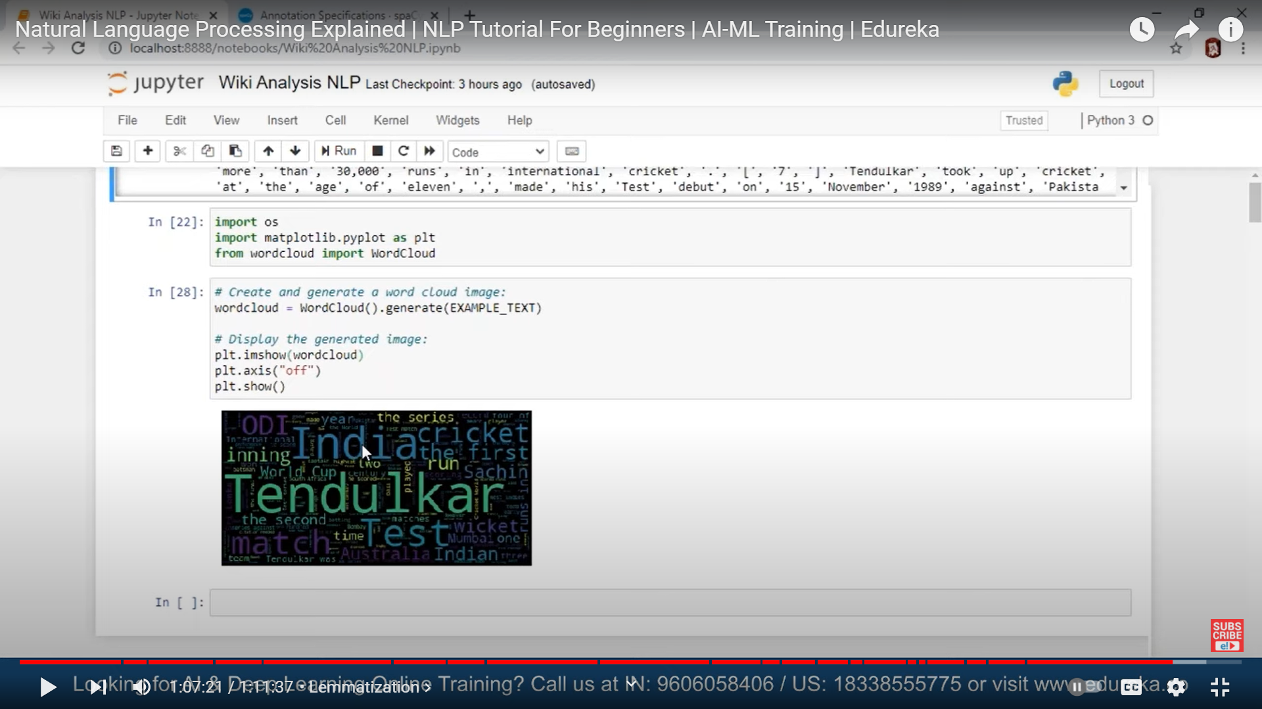

POS (Parts of Speech)

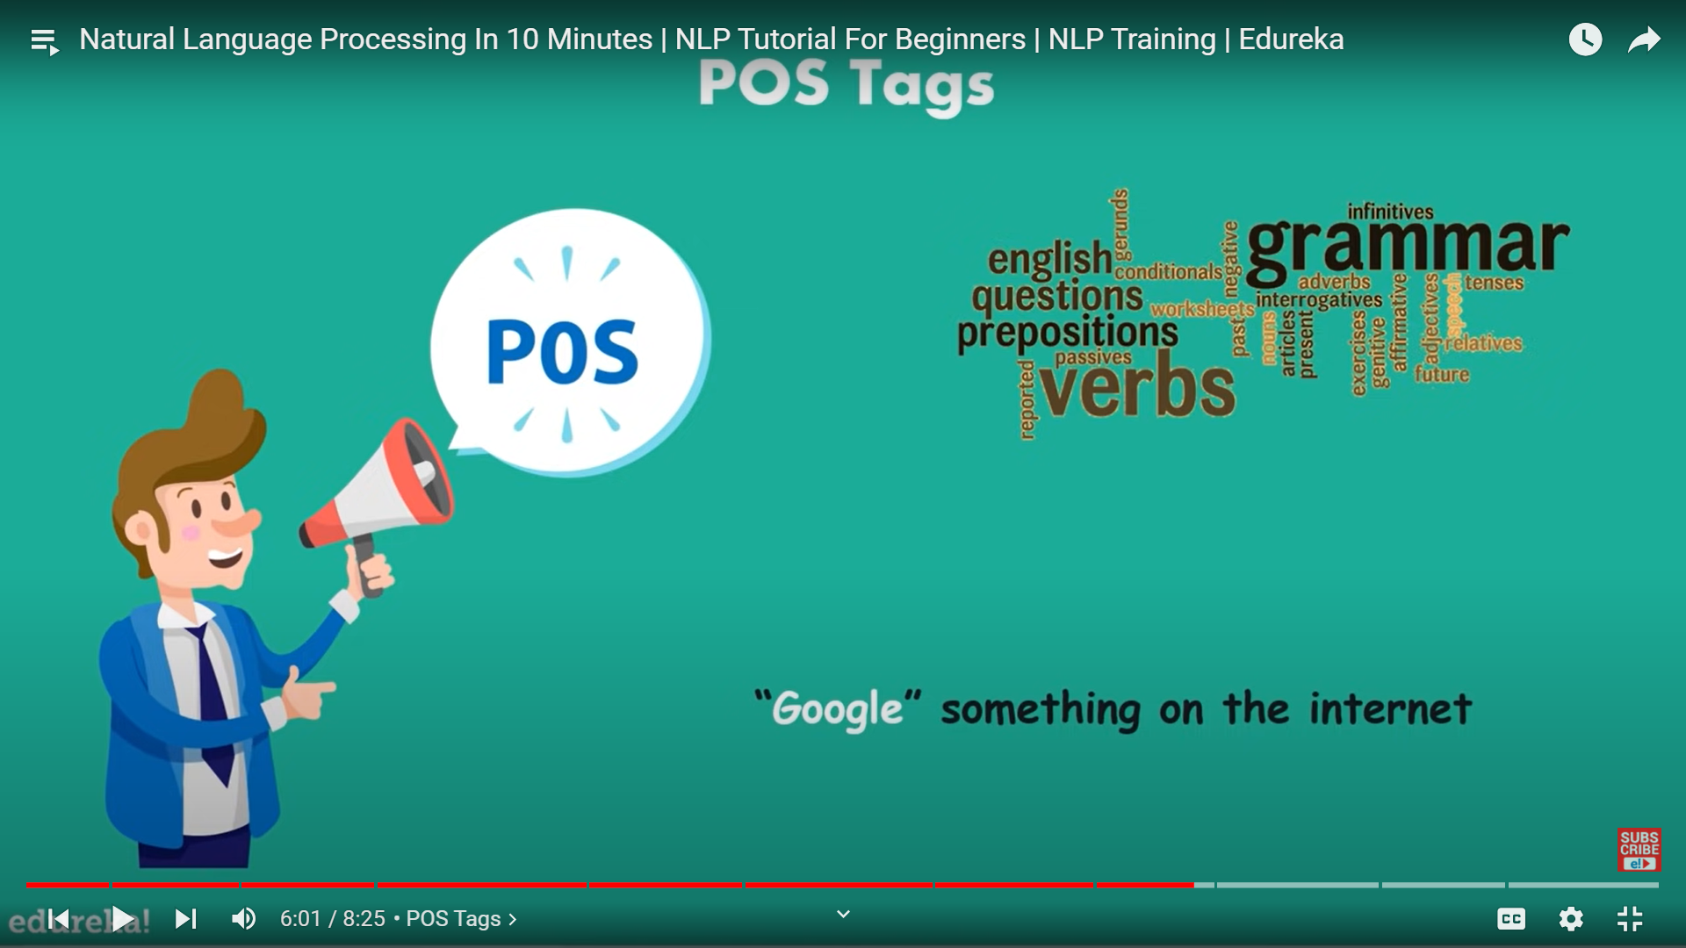

Here google is noun but it consider as verb

To overcome all of this we got

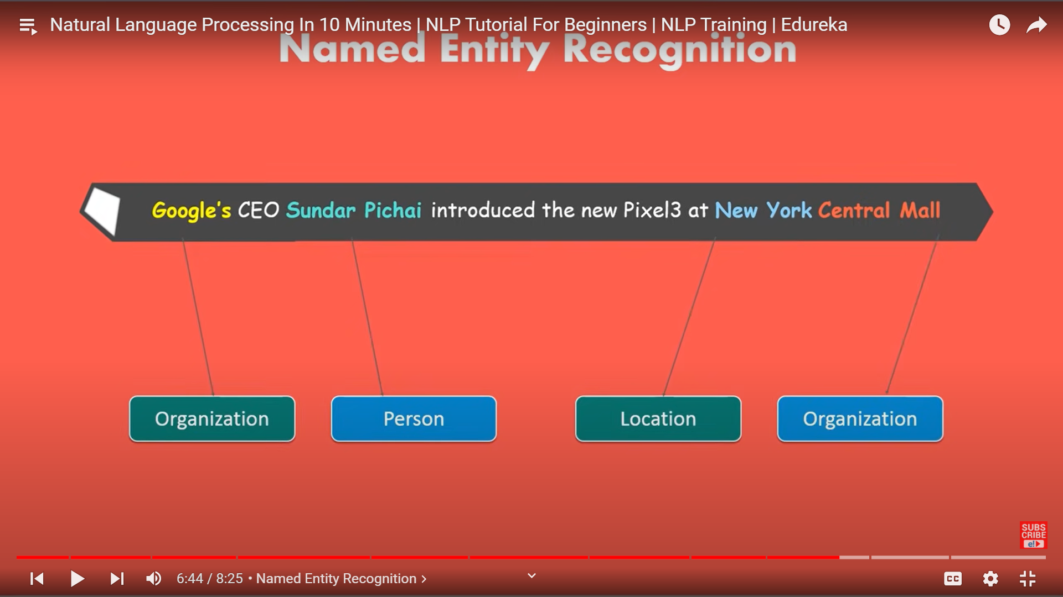

CHUNK:

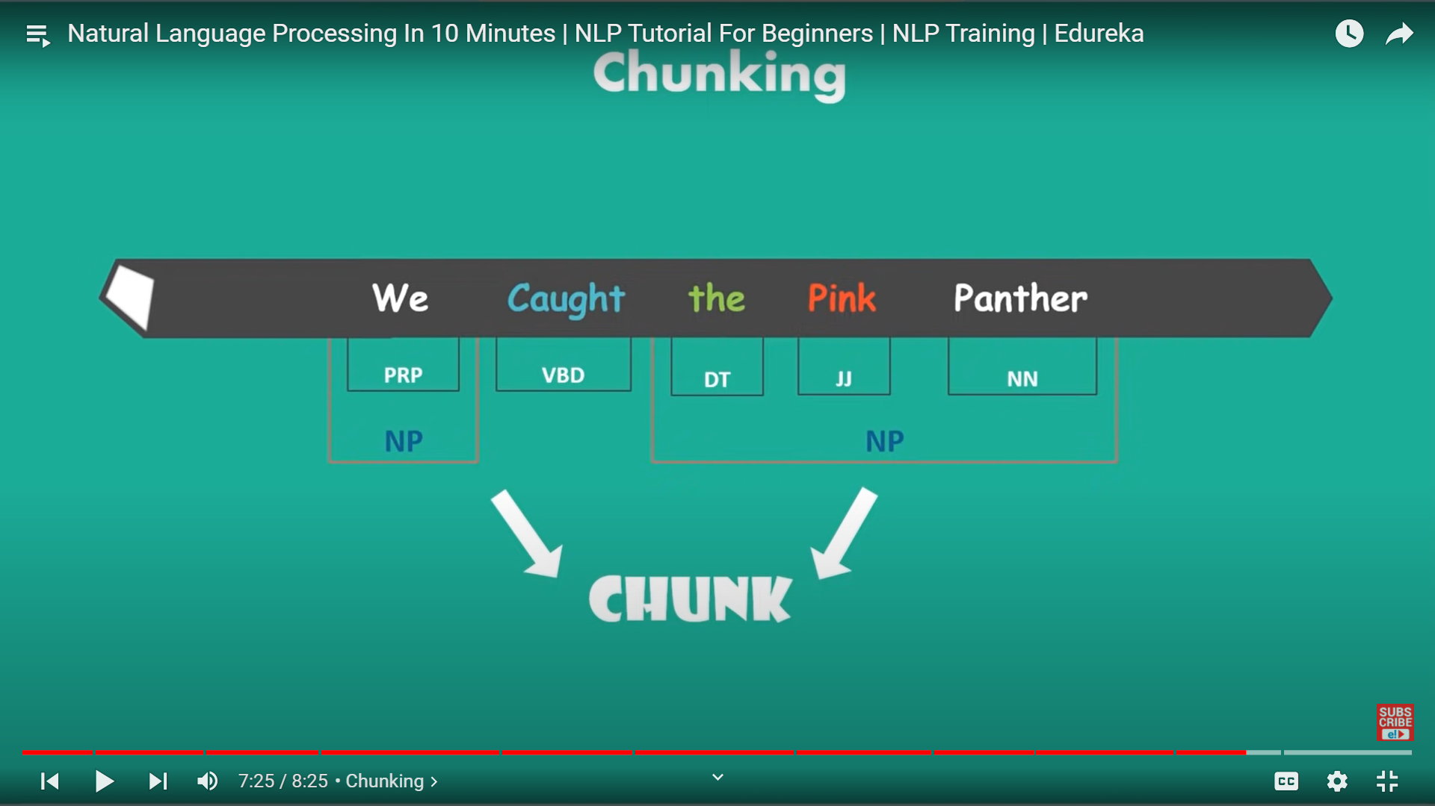

Gp the token or word is chunk

APPLICATION

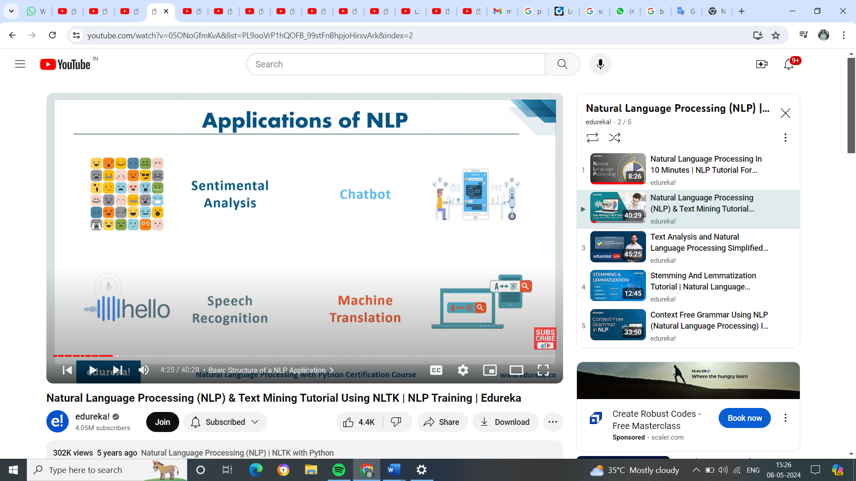

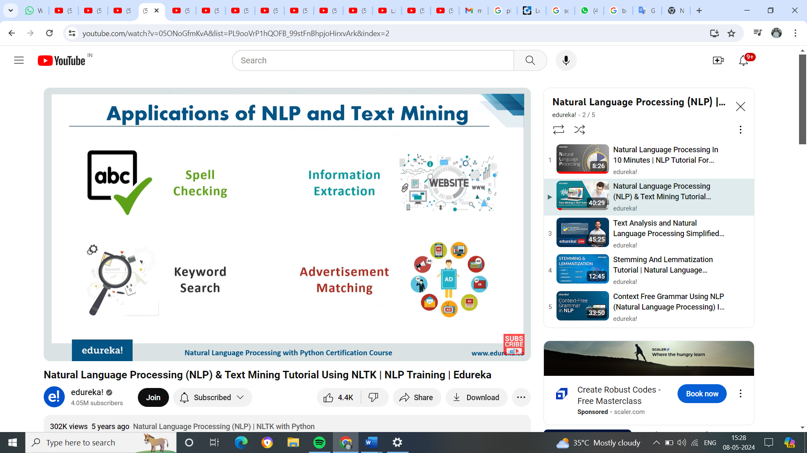

Recommendation of ad based on history

Bag of words means – creating the matrix – drawback is – there is no much semantic meaning / difference b/w words)

It take the sentence and convert into count of vector of feature

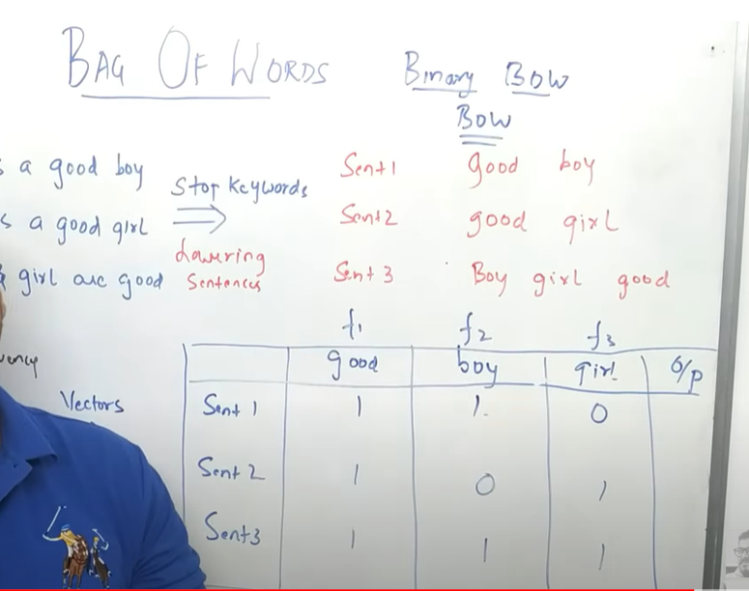

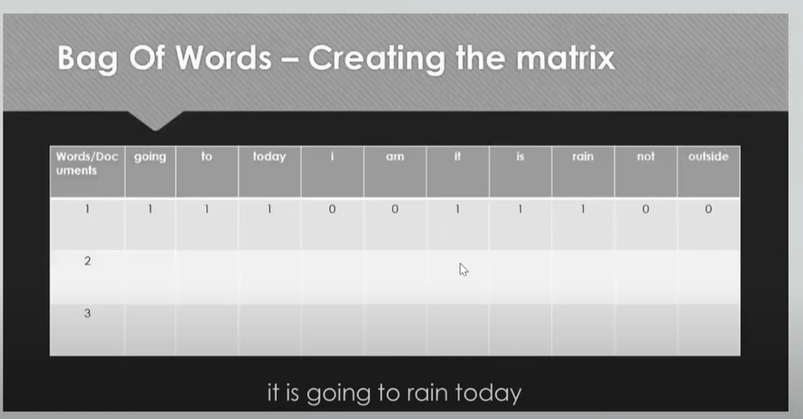

It is not giving any diff weight to word, so we move to TF-IDF

**Word2Vec**

**Semantic words – while creating matrix in bag of words , it won’t follow the order / relationof the word / sentence**

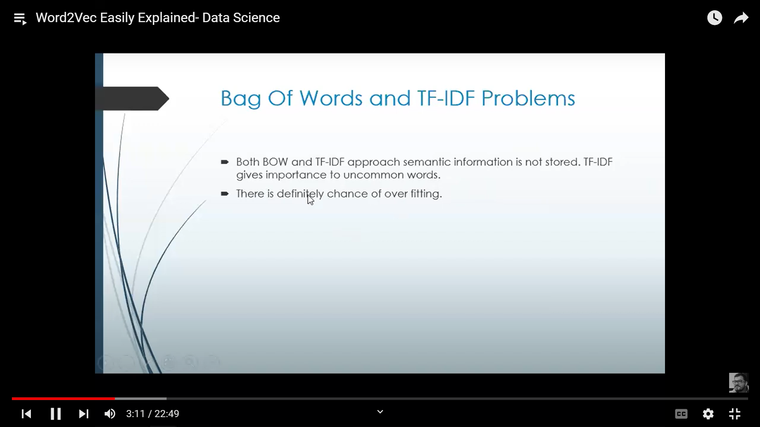

**Dis-advantage of TF-IDF**

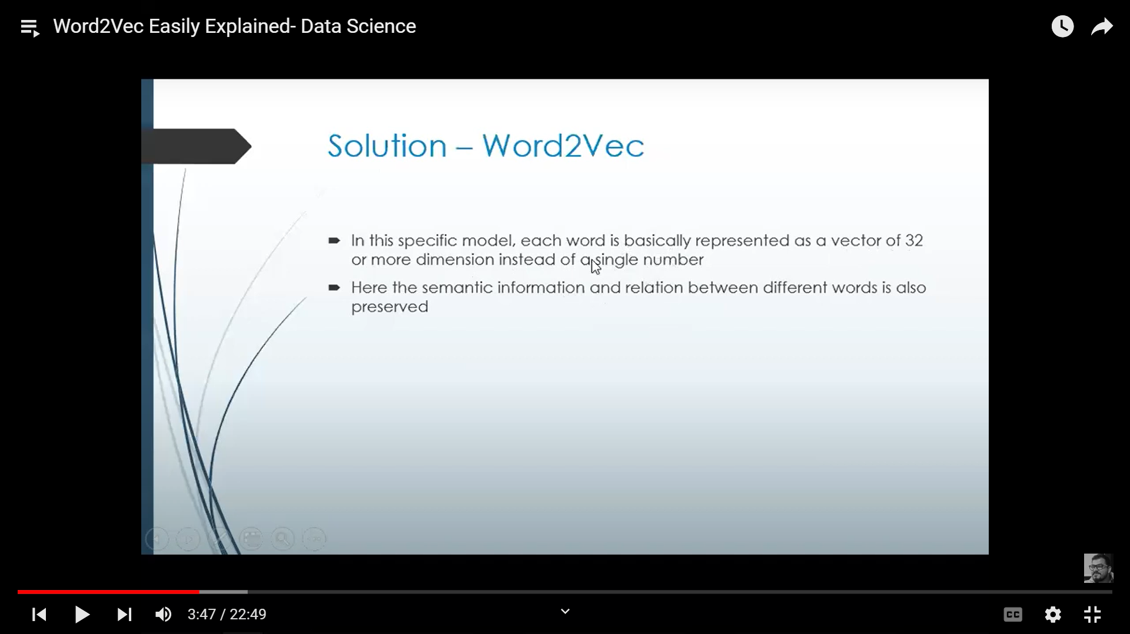

**TF-IDF**

Term Frequency - Inverse Document Frequency (TF-IDF) is a widely used statistical method in natural language processing and information retrieval. It measures how important a term is within a document relative to a collection of documents

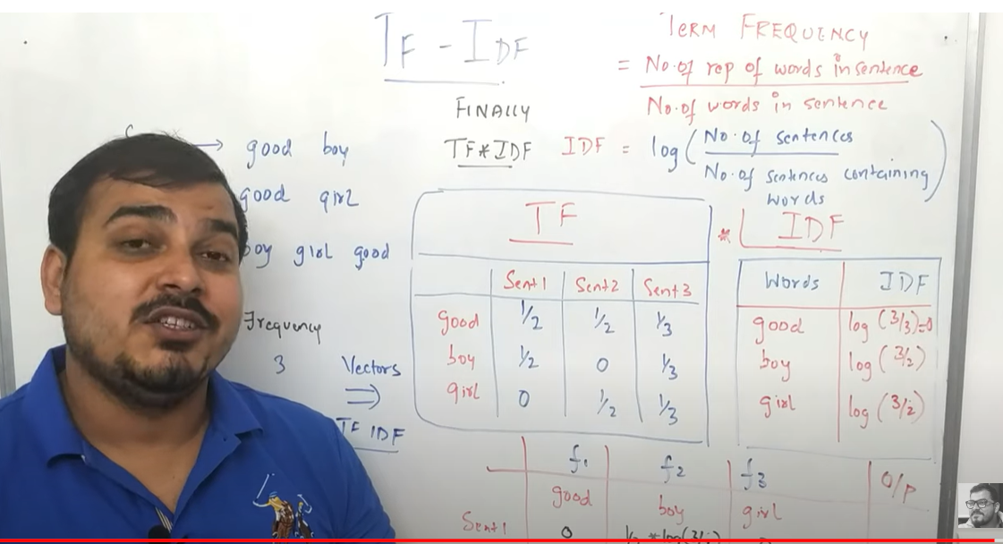

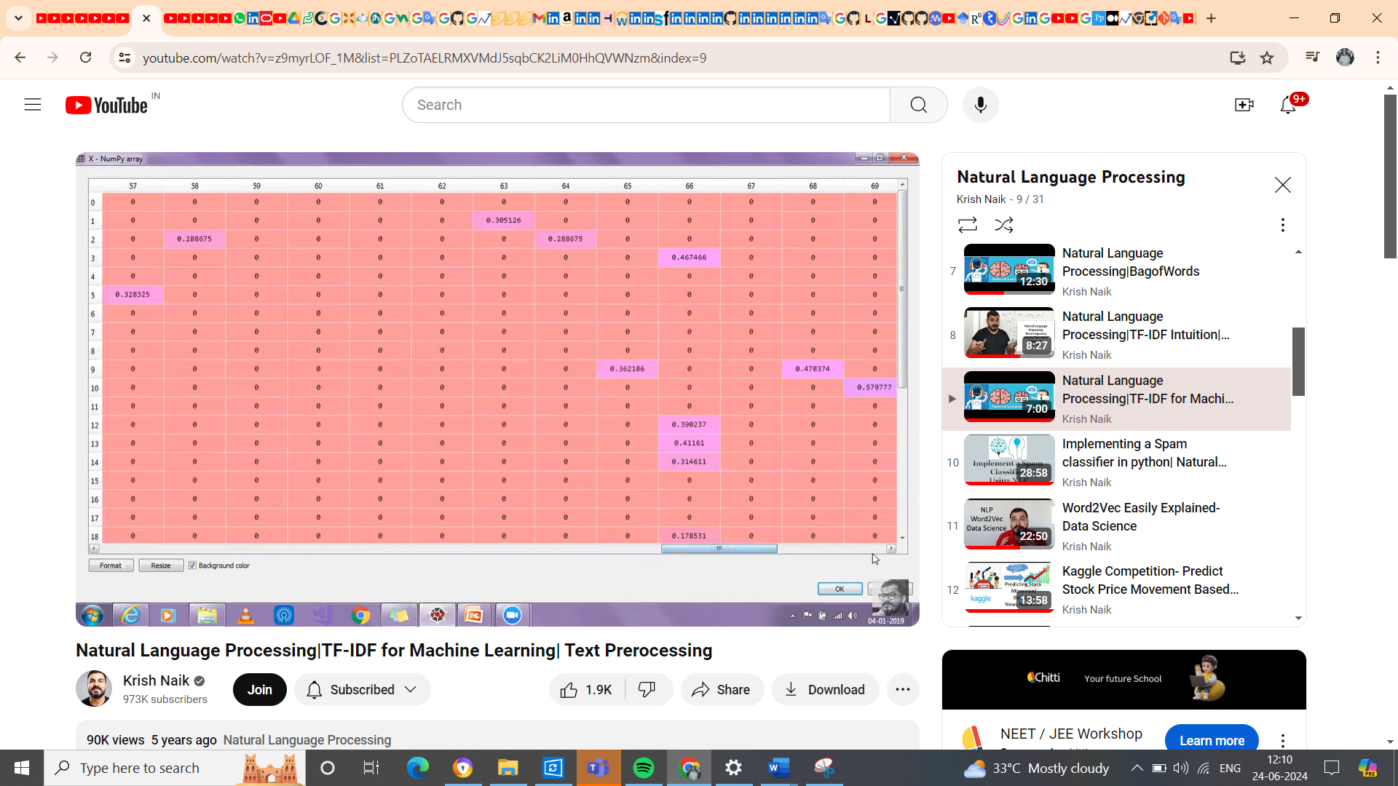

Dataset source url

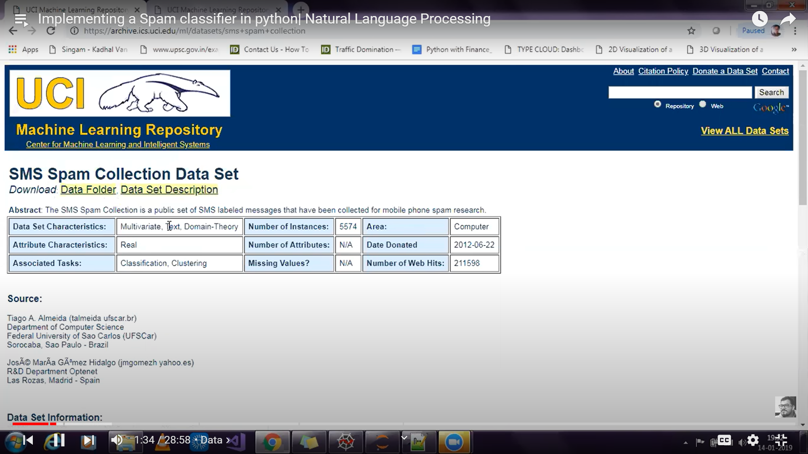

**Highlights**

**In NLP always 1st is clean the data**

**2nd – lower the word**